**Report of final project:**

**“温州剧本杀俱乐部“**

Tingyu ZHENG

<https://tingyuzheng.pythonanywhere.com/>

## Problem Background

**Problem introduction:**

Scripts murder game has become an important way for young people to socialize and have fun these days. Under the influence of factors such as increased demand for popular entertainment, scripted murder game has expanded rapidly, with its market size reaching11.74 billion yuan in 2020. This number continues growing and the market has a very promising future. This game has gained popularity among consumers for its sense of excitement, fun, and social functions, and as a result, has generated a very large number of avid fans. Among script murder game players, 约本 is a popular activity. It basically means to play a script murder game with other stranger fans who share the same interest in testing that script.

However, in the second tier and third tier cities, the market of this leisure activity still has a very huge potential to develop. Although script murder games are getting more and more known by the public, players are facing a series of problems. For one thing, there is no platform that gathers all related information. People need to look for information, generally incomplete and inconsistent, on different platforms, combine and compare it manually, which is a waste of time. For another, it is difficult for individuals to communicate with other players or organize 约本 activities as they want

Therefore, a platform with integrated information about venues and scripts is required to meet the needs of script murder game games players in different scenarios. They can find important details of venues and information of scripts on one website so that they can quickly browse for scripts and venues to choose one that interests them. Meanwhile, an online community is also required to be built for individual enthusiasts to communicate with each other, share experiences, meet with strangers and realize 约本 activity.

**Target Market:**

**Adjustments in the target market:** At first, Shanghai was chosen as the target market, but after collecting data, it turned out that the information source was less or more sufficient for players to carry out a 约本 activity, which would lead to a less competitive business model.

Taking this into consideration, the target market was changed to Wenzhou. It is a second-tier city where people have a high standard of living and the per capita consumption level is high. Because it is a relatively small city, there are limitations on residents’ entertainment choices, thus script murder game has become a more popular activity for young people. Nevertheless, the information source is limited, so the target persona has stronger needs for an integrated platform combined with an online community. On the other hand, since it is my hometown, I have several connections related to script murder game venues.

**Target Persona:**

**Adjustments in the target persona:** In the first stage, people who seek to play a script murder game in their leisure time were chosen as the target persona and several interviews were conducted to find out the problems (see Figure 1). Therefore, the first prototype was built to solve the problem of information fragmentation and scatteration.

Nevertheless, after having conversations with a venue owner, it turned out that the largest part of the revenue comes from customers of loyalty, in other words, those scripts murder game enthusiasts. At the same time, these enthusiasts are always looking for buddies to play scripts murder games together, especially when it comes to those new limited special scripts. With this in mind, the target persona was changed to script murder gamers who want to carry out 约本 activities in their leisure time (see Figure 2).

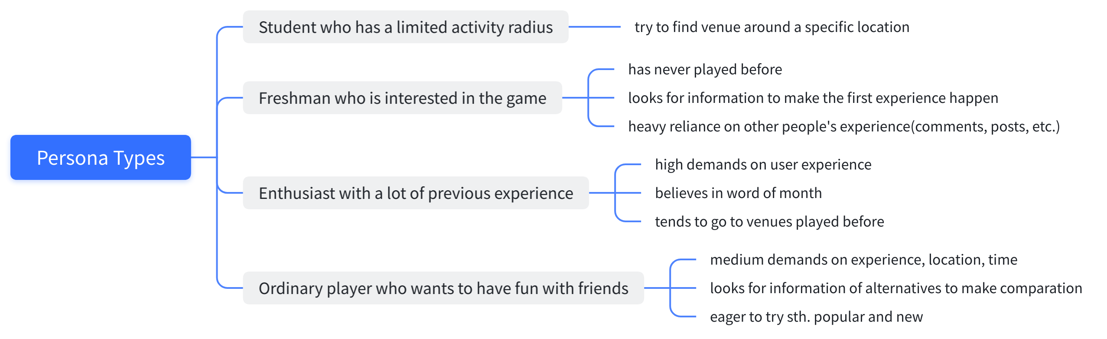

*Figure 1: previous persona types*

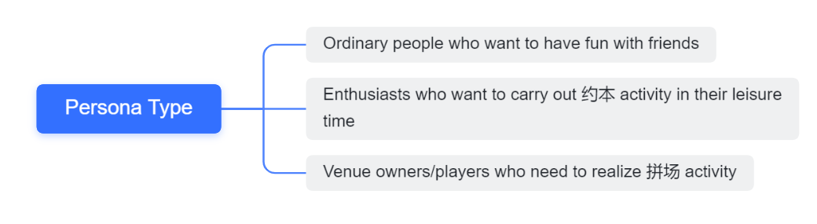

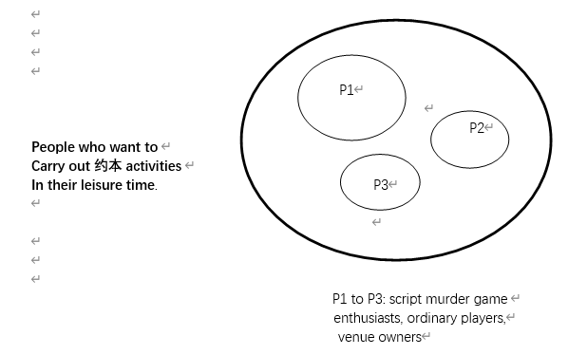

*Figure 2: final version of persona types*

Nevertheless, interviews on previous types of persona are still important parts to propose the problem settings, requirements and positioning map, since gathering information for scripts and venues is a necessary part for every persona that would like to play the script murder games.

**Persona Type Picked: Enthusiasts who want to carry out 约本 activity in their leisure time**

This persona type was chosen because he/she contributes most to the revenue of the venues. They are youngsters with age among 18-25 and own a high standard of living. The money spent on script murder games per month by them reaches from 500-4000 Chinese yuan. They are most urgent on playing script murder games, testing out exclusive scripts, meeting other stranger players, carrying out 约本 activity, and thus have stronger needs of an integrated platform and an online community that they can belong to. People use this game as a social event and use it to gather friends or make new friends. They consider it as a long-turn-run hobby to develop.

**Requirements:**

|  |  |  |  |  |
| --- | --- | --- | --- | --- |
| **Functional** | **Venue Information** | **Script Information** | **Buddies to play with** | **Comments and other references** |
| **Content** | *Location:*  1.Detailed location  2.Possible ways of getting there | *Attributes:*  1.Scripts type  2.Number of players required  3.Scripts introduction  4.Duration of time | *Attributes:*  1. Where can I find buddies with the same interest to test out a script?  2. Is there any online community built especially for script murder game players?  3. How can I communicate with other players and plan a 约本 activity? What else information can I exchange with them? | 1.Which platform to put on comments?  2.Where can I find activity information of different venues?  3.Where can I post my experiences and communicate with other players?  4.Will I get any coupons if I post detailed comments? |
| *Service:*  1.Scripts provided (special? new? exclusive?)  2.Time availability  3.Cost  4. Any discount activities?  5. Any activities?  6. Any community to join in? | *References:*  1.Players' comments on the scripts (Is it genuine? Is it clear to understand?  2.Recommendations  3.Does it up-to-date or popular or exclusive? Anything special? |
| *References:*  1.Comments about the chosen venue (environment, service, dm, scripts) |

Since the 约本 activity has been added to the process of the persona, a new revised version of customer journey map and story map have been developed with new sessions of “plan 约本 activity” and “carry our 约本 activity” added on it.

**Previous Customer Journey Map & Story Map:**

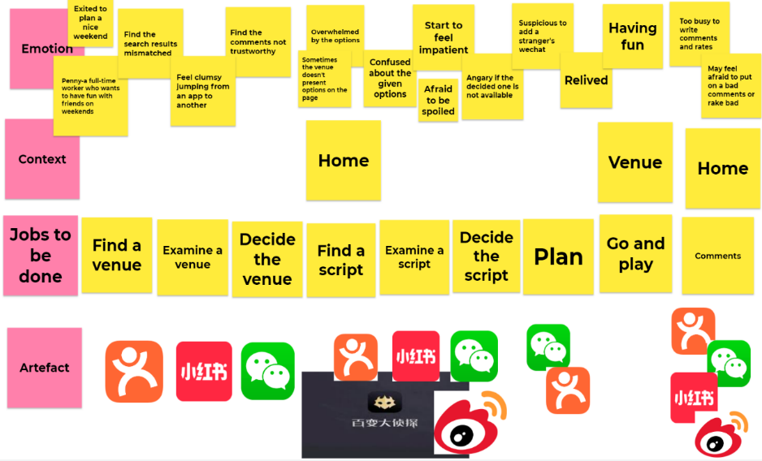

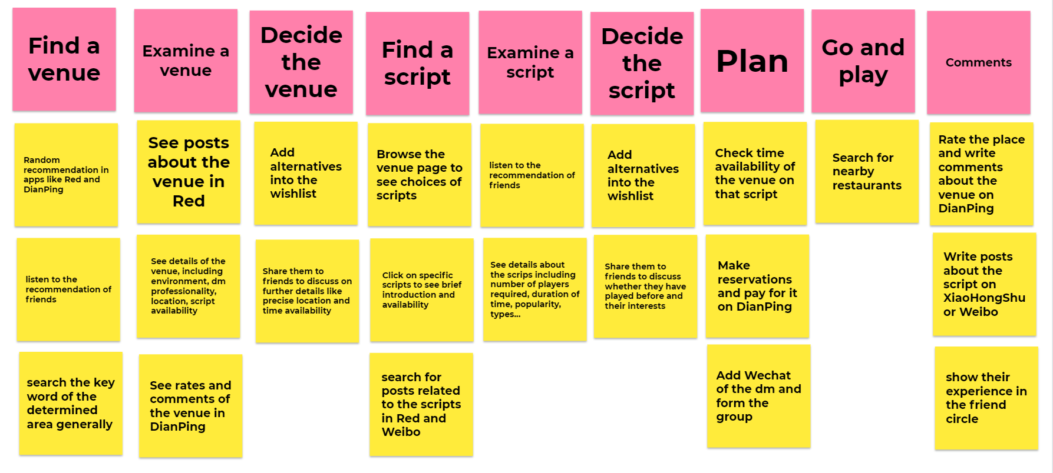

**Revised Customer Journey Map & Story Map:**

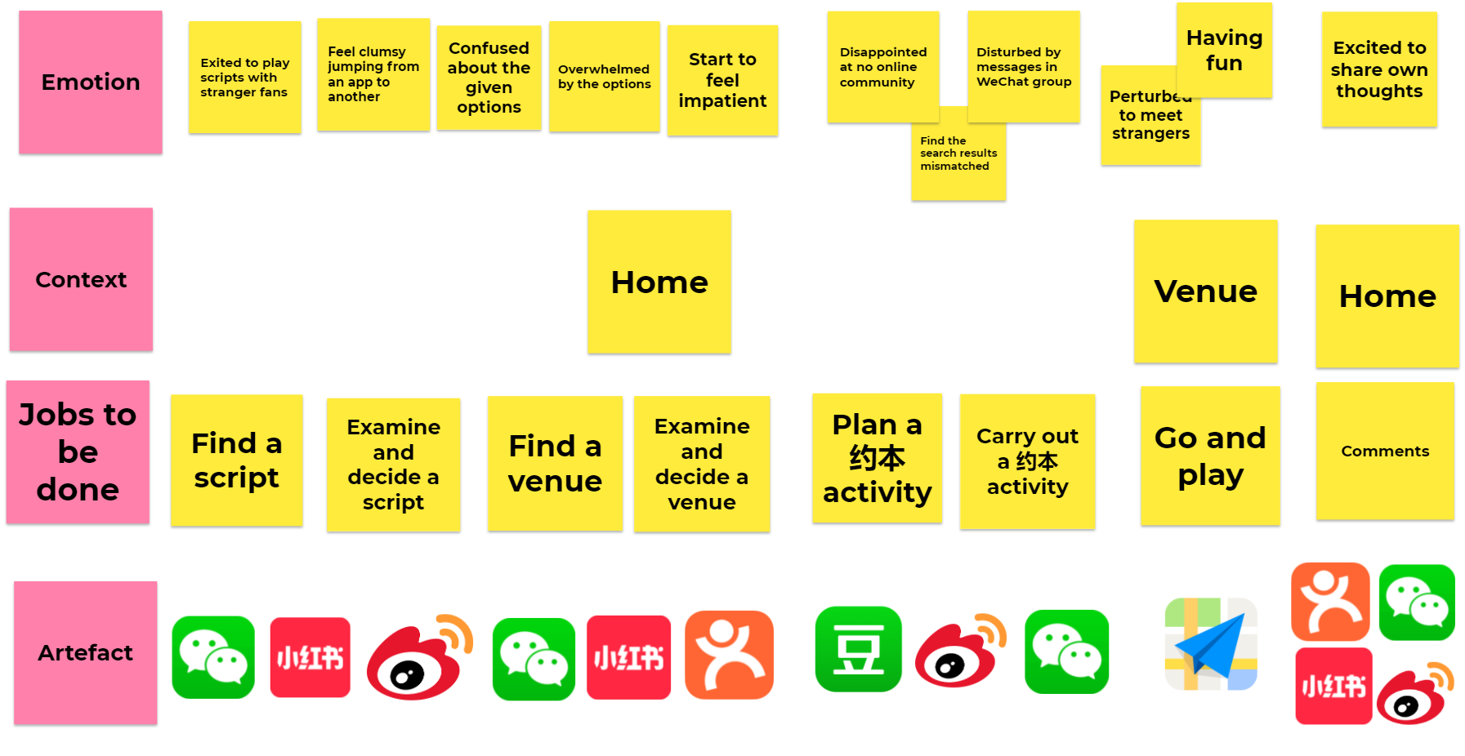

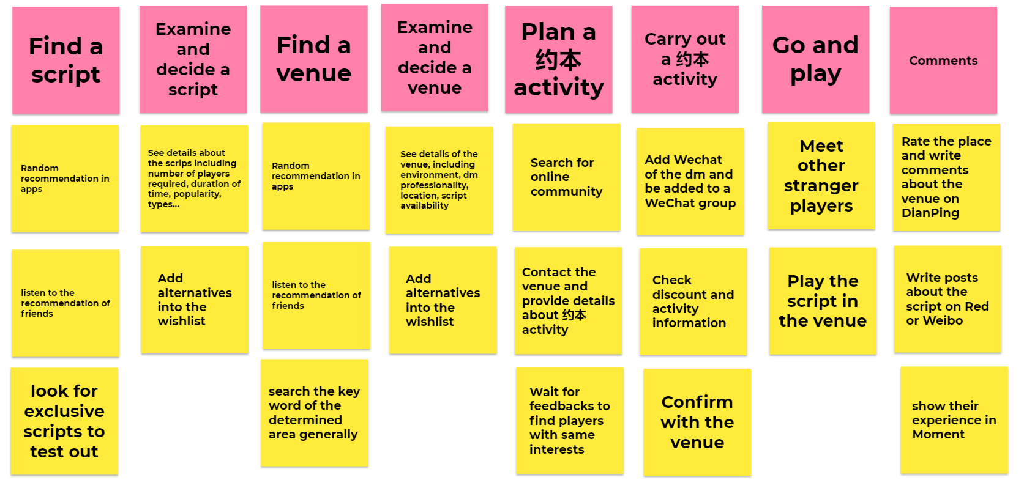

**Problem setting:**

1. Scattered information source: the information is fragmented and has to be found in different dimensions; it is a waste of time to gather information from different sites.

2. Lack of useful information related to 约本 activity in Wenzhou: no useful information can be found about 约本in the case of Wenzhou by searching. The search engine returns useless information that has nothing to do with the needs (see Figure 3). At the same time, in Dianping there is a lack of 约本 information in the case of Wenzhou (see Figure 4). Therefore, the persona has to contact venues, add WeChat and ask for information. Sometimes they have to add more than three WeChat accounts to finally realize a约本activity.

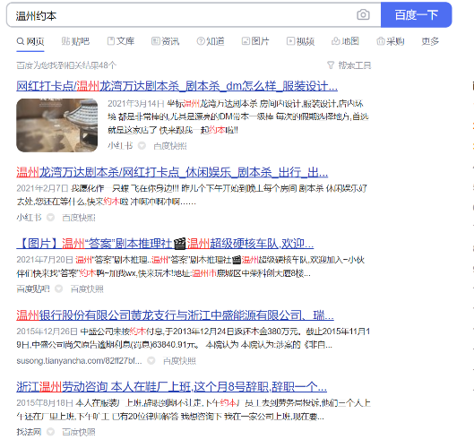

*Figure 3: results shown on the most popular search engine in China of 温州约本*

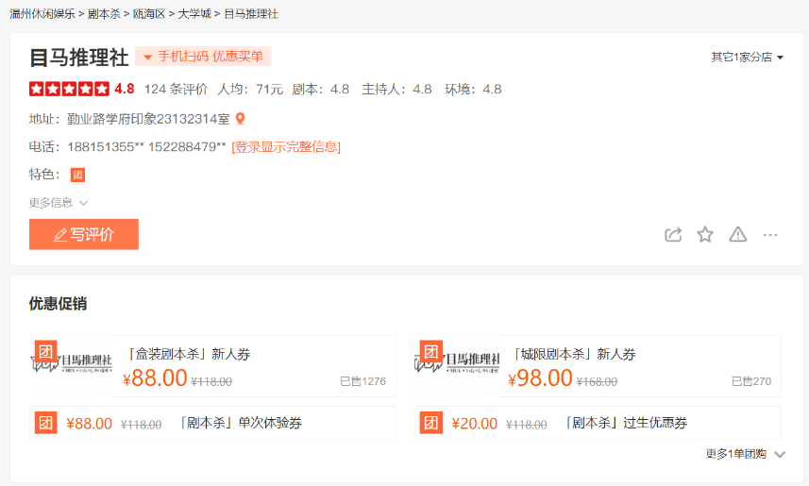

*Figure 4: undetailed information of venues shown on the Dianping page*

3. There is no public online community for script murder game lovers in Wenzhou (see Figure 5). Communities of 约本are always built by venue owners and players’ choices have been limited. What’s worse, these groups are always disordered, and people chat about unrelated things (see Figure 6). The target persona found it disturbing to be added to this kind of groups with the aim of realizing 约本 activities.

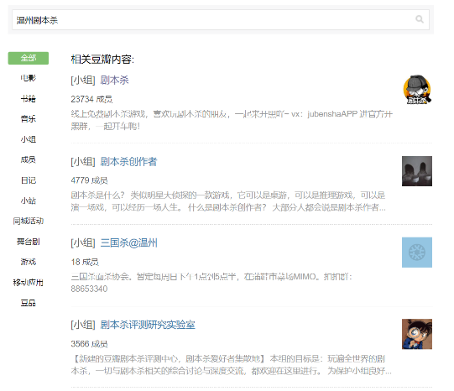

*Figure 5: China’s biggest online community platform “豆瓣”’s results on温州剧本杀*

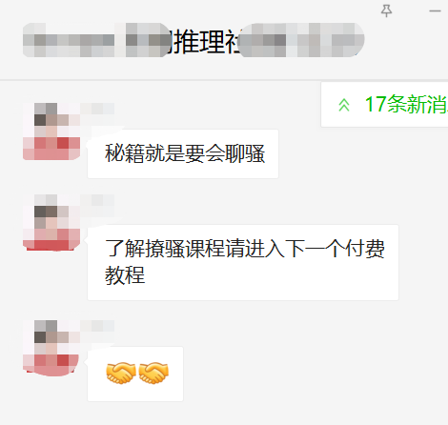

*Figure 6: daily chatting content of a WeChat group formed by a venue.*

**Problem Statement**

How might we make a script murder game fan who wants to plan约本activities (who) address the problem of scattered information, lack of source about 约本 activities and online community (what) so that she/he can realize 约本 activities with other players (why)?

**Card sorting**

**Participants' test:**

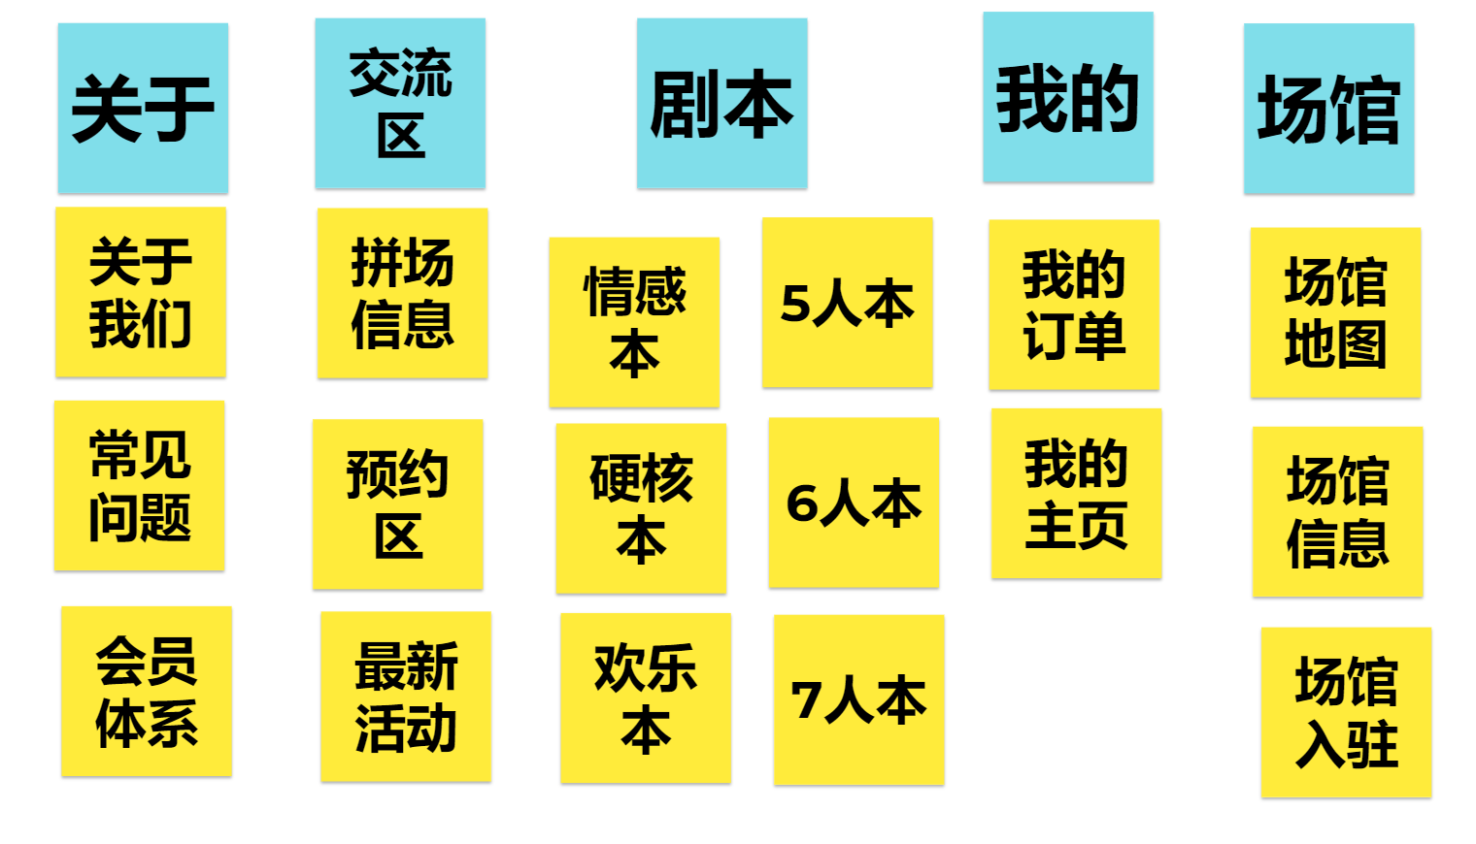

**Organized result:**

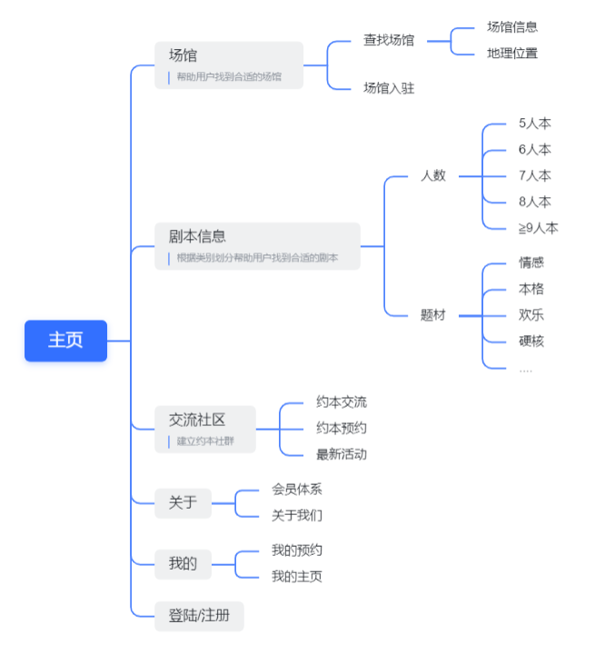

**Positioning Map**

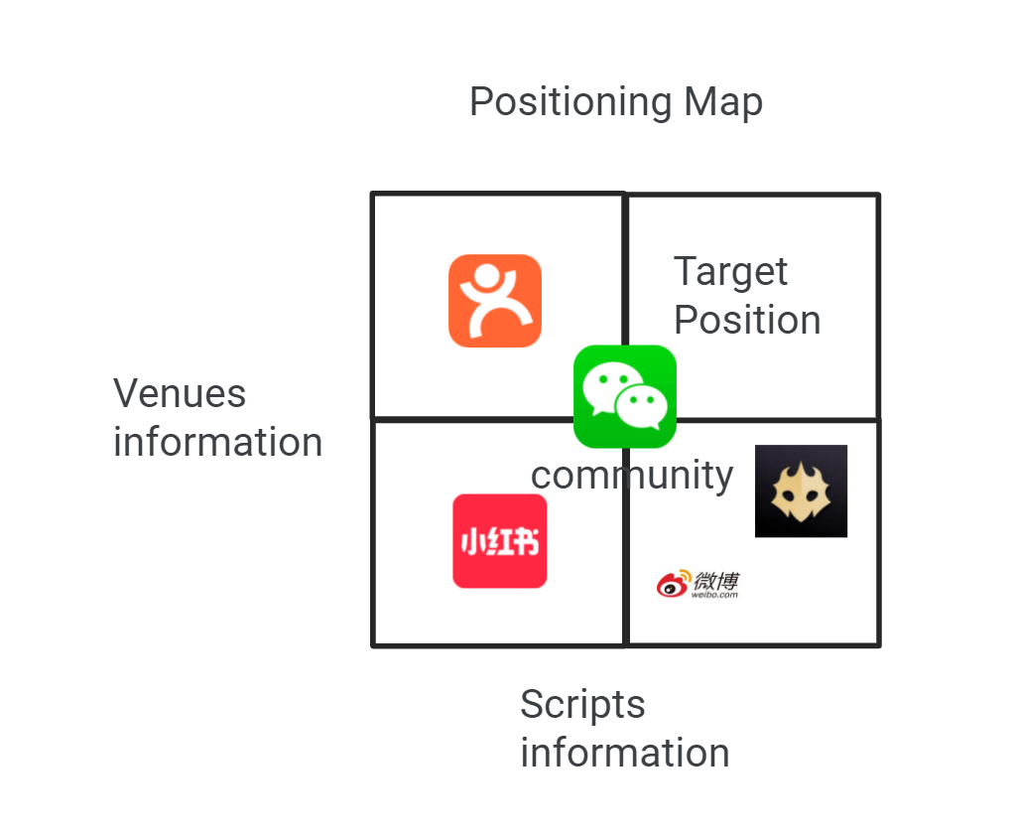

## Design

Based on the problems and requirements discussed, as well as the position map proposed, the website is designed to achieve two major functions:

1. integration of information related to scripts and venues
2. online community for script murder game players to carry out 约本 activity and exchange information.
3. **Integration of information related to scripts and venues**
4. **Information of scripts:** users can look for scripts’ information according to the number of players required and type of scripts. They can either enter the page of specific kind of scripts by browsing dropdown menus in the navigation bar (see Figure 6) or by clicking on the “scripts collection” button on the homepage (see Figure 7) and choosing the kind of scripts they want (see Figure 8).

**

*Figure 6: “scripts collection” in the navigation bar*

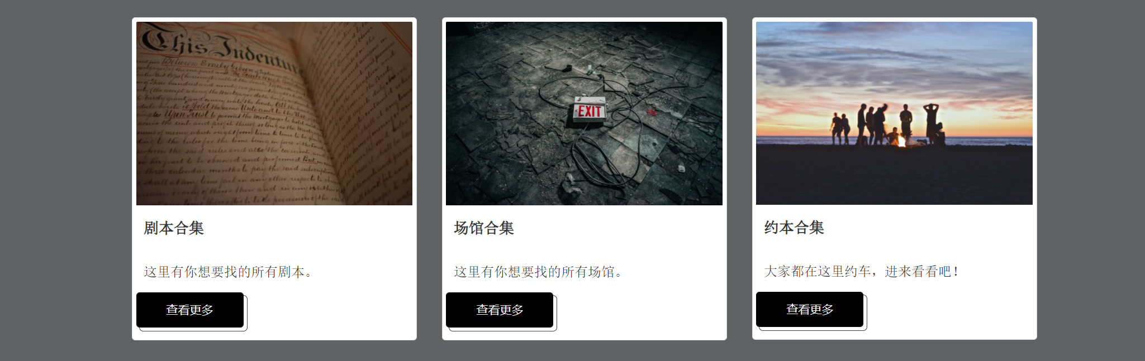

*Figure 7: “scripts collection” on the homepage*

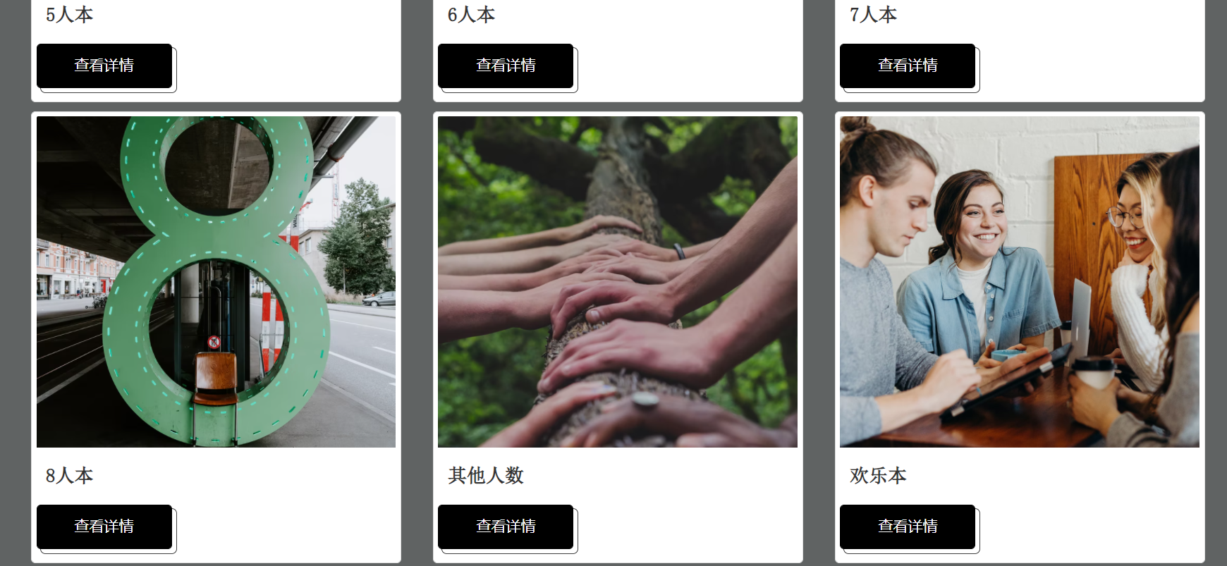

*Figure 8: classification of scripts*

After entering the scripts page, users can briefly browse for information of scripts The brief information shown on the screen are script name, brief introduction, types of the script, number of players required and author (see Figure 9). If specific script interests them, they can click on the “view more” button to see detailed introduction about the script. A modal is designed to show up after clicking (see Figure 10).

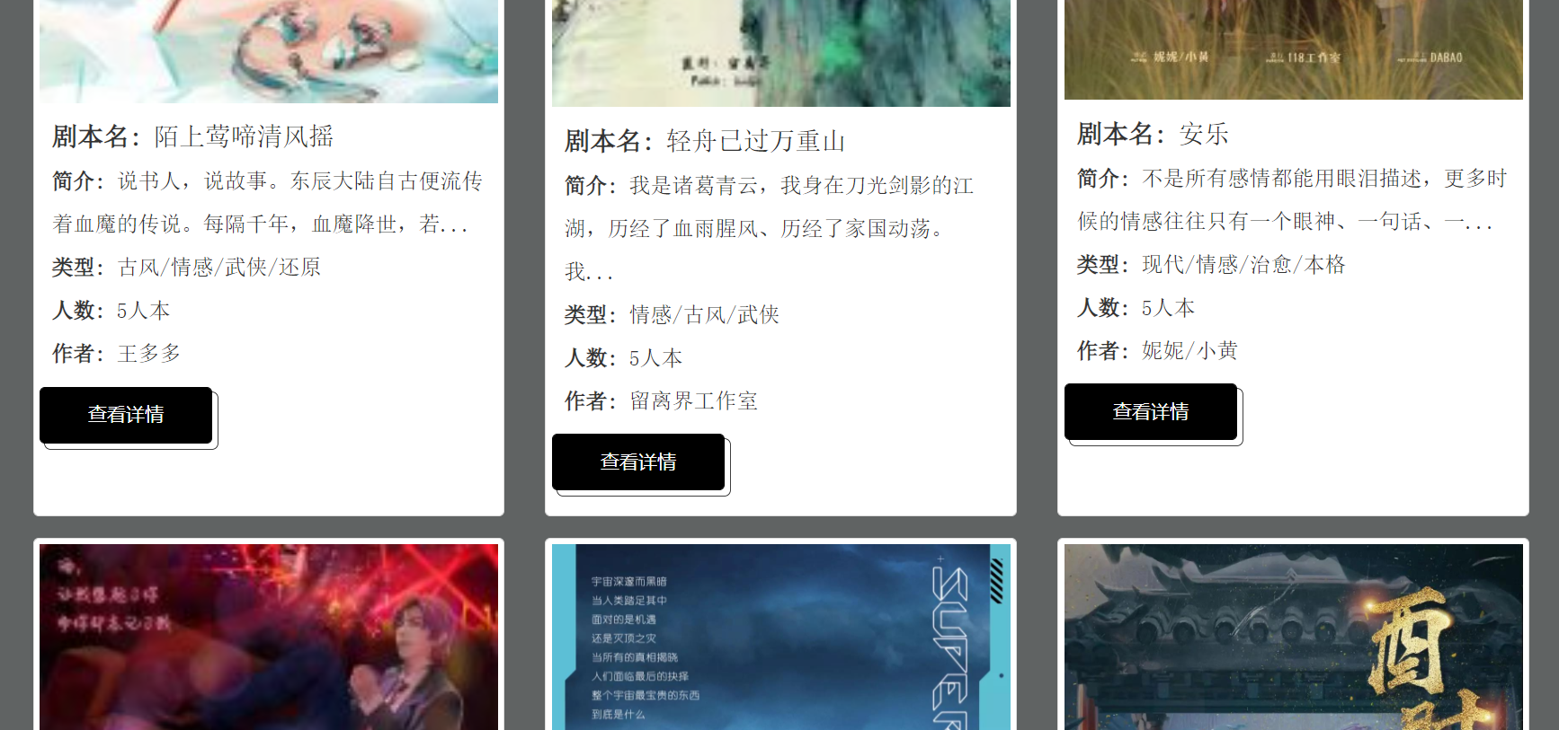

*Figure 9: brief information shown of scripts*

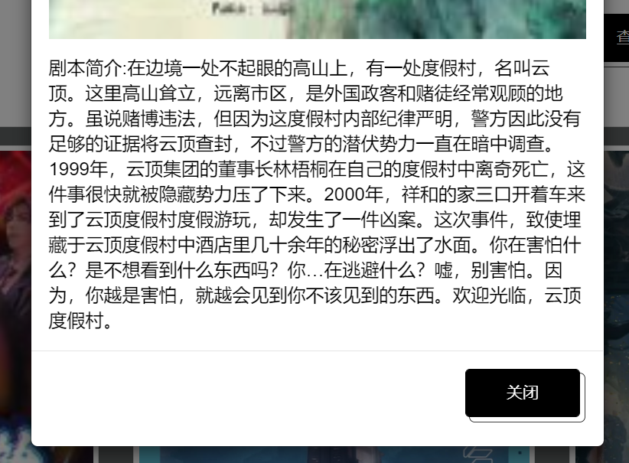

*Figure 10: detailed information of scripts on the modal*

1. **Information of venues:** the way of entering the venue page is the same as the script page, from navigation bar (see Figure 11) or from the homepage (see Figure 12).



*Figure 11: “venues collection” in the navigation bar*



*Figure 12: “venues collection” on the homepage*

There are two major functions designed on the venue page: information related to venues in Wenzhou and locations shown on the map. Users can firstly browse for brief information related to venues in Wenzhou (see Figure 13). The information shown on the page is venue names, rating, price per person, and district. Users can look for venues that are most convenient for them according to the information provided on the page. They can click on the “view more” button to see detailed information about the venue including recent activities, detailed address, and contact number (see Figure 14). On the other hand, they can also go to the map area to find out the location of venues on the map (see Figure 15). This function serves as a reference and helps them have a clearer picture of the distribution of Wenzhou script murder game venues. The venue page helps fulfill the requirements of the venue information.

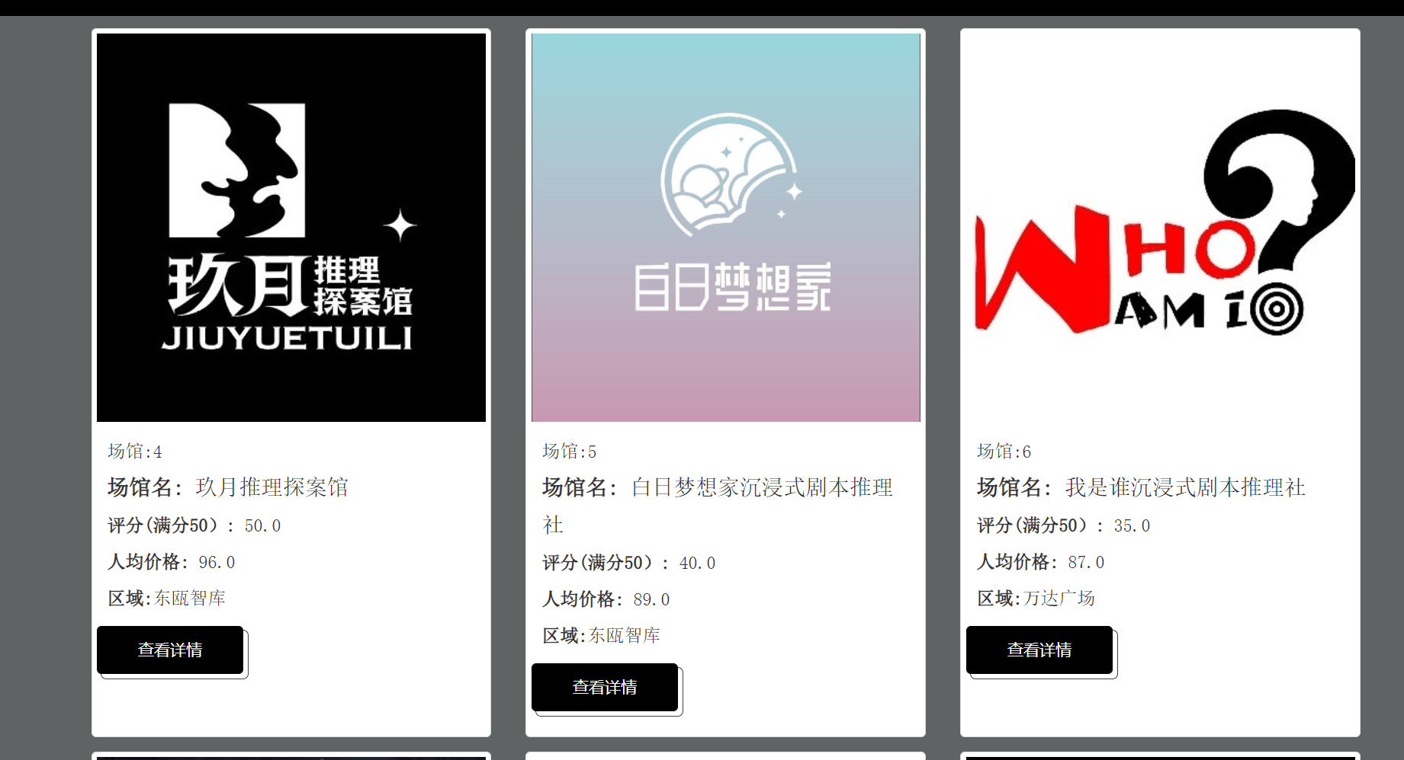

*Figure 13: brief information shown of venues*

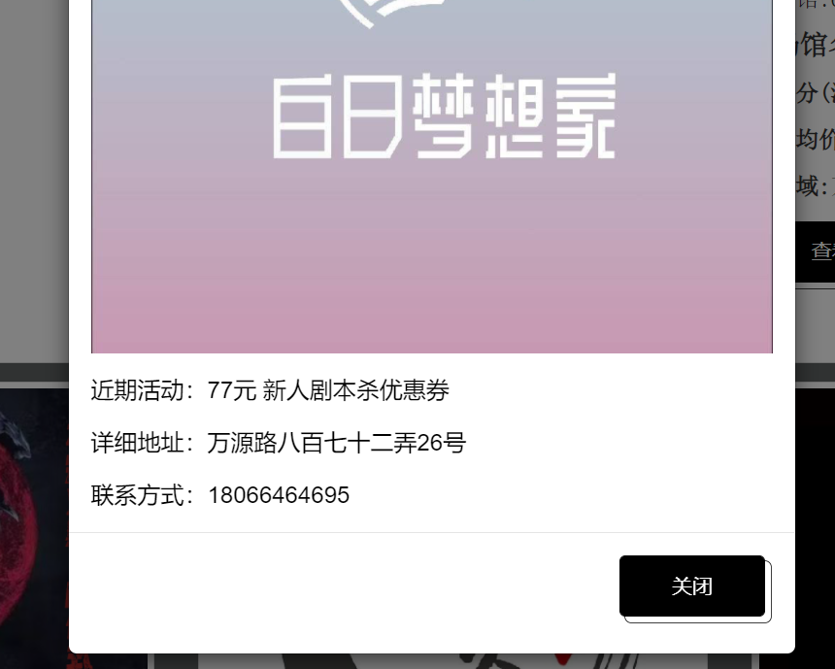

*Figure 14: detailed information of venues on the modal*

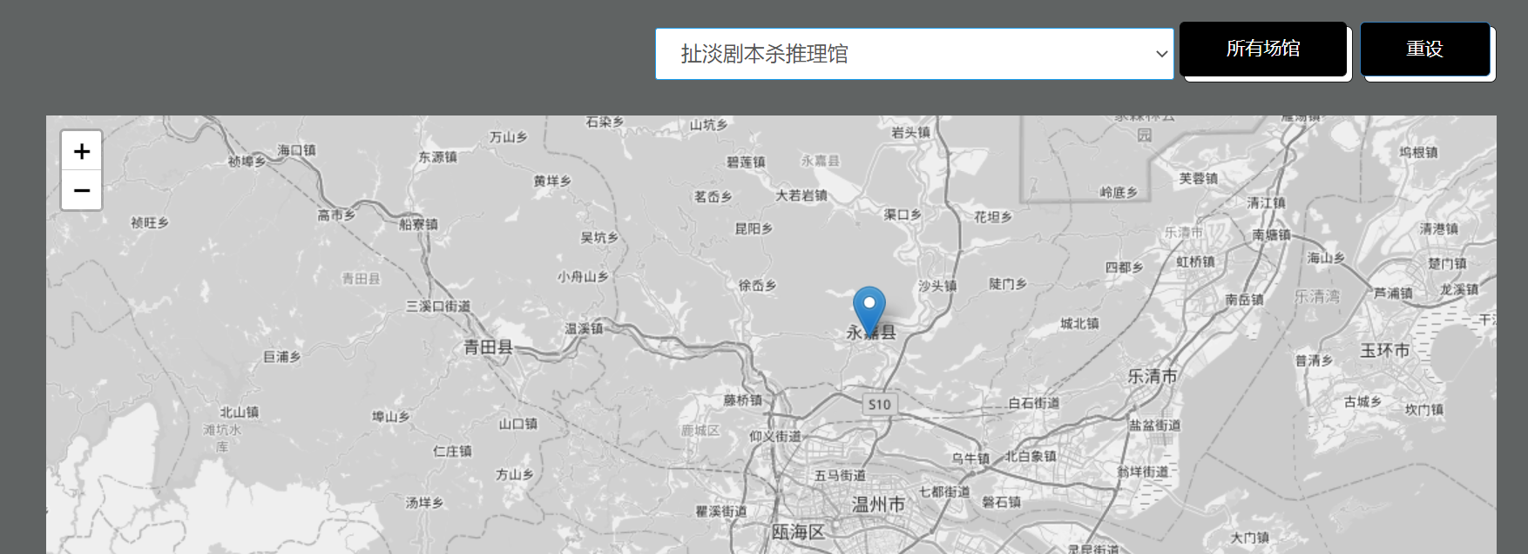

*Figure 15: map function on the “venues collection” page*

1. **Online community for script murder game players to carry out 约本activity and exchange information**

The way of entering the community page is also the same, from navigation bar (see Figure 16) or from the homepage (see Figure 17)



*Figure 16: “约本” in the navigation bar*



*Figure 17: “约本collection” on the homepage*

There are three major functions on the forum page: discussion forum, appointment area and advertising session.

1. **Discussion forum:** in this area, members are invited to post their activity invitation, comments, and feedback related to their activity experience. Only registered members can add a new post on the forum (see Figure 18 & 19). Members can write a brief introduction and details including script name, venue or district, date and time, and the number of players required related to the activity that they want to carry out, and the post will be added to the forum. They are also invited to write down comments and reviews related to the activity experience in this area.



*Figure 18: messages flashed for non-registered members*

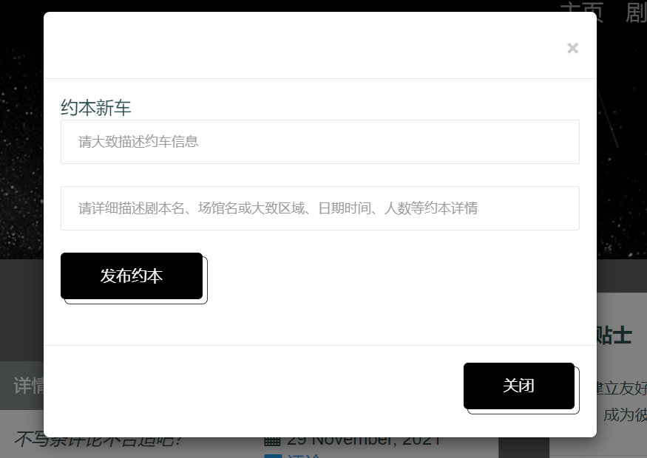

*Figure 19: fill-in form appeared for registered members*

On the other hand, if the posts on the page interest them, they can click and enter to the discussion page of that post (see Figure 20). Only registered member can post comments on the page to further discuss with the author. They are invited to communicate with each other on the page to get to the agreement of 约本 activity.

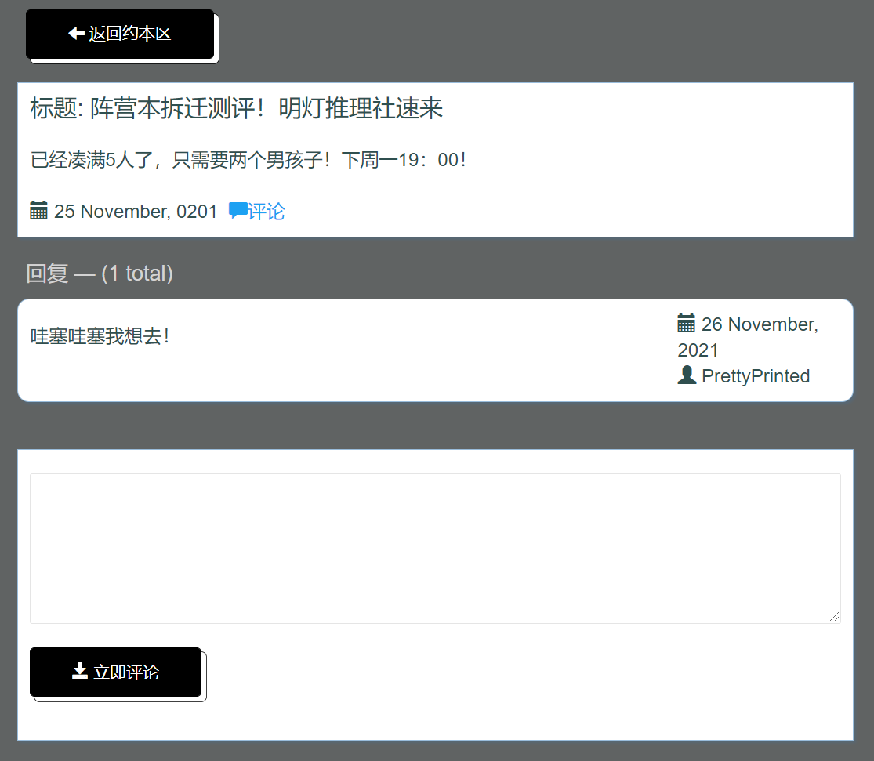

*Figure 20: detailed page for each post*

1. **Appointment area:** After having matched buddies to play the script murder game, they can make the appointment directly on the same page. After clicking the “appointment” button, a form will show up for them to fill in the activity details including script, venue or district, date, time, number of people they have, number of players they lack and their contact number (see Figure 21). After receiving the appointment request, the platform will help contact the venue and organize the activity. Their activities will also be posted on the page, serving as a reference for other players to consider and join (see Figure 22).

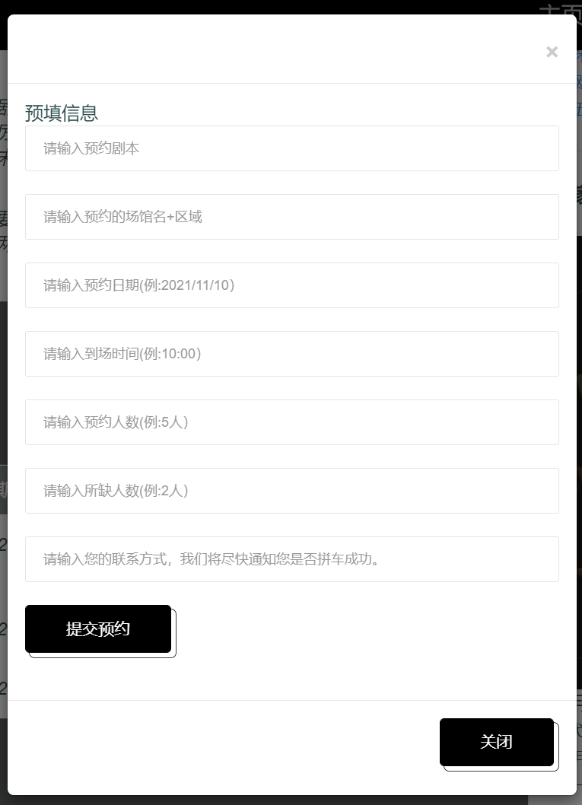

*Figure 21: fill-in form for appointment*

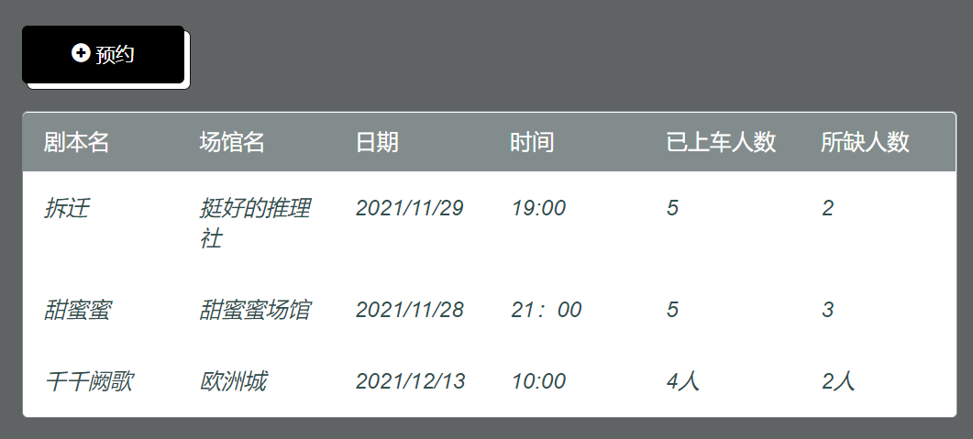

*Figure 21: details of appointments shown for reference*

1. **Advertising session:** the third function is designed for venues to advertise their exclusive scripts. The advertising session is put on the main sidebar. This session is not only important for venue owners to attract traffic and show their difference in positioning, but also crucial for script murder game enthusiasts because they are keen on testing out new exclusive scripts since they are early adopters and heavy users of scripts. Information related to the exclusive scripts will be posted and users can click on the “view more” button to see details of that script as well as click on the “appointment” button to make the appointment of that script with that venue (see Figure 21).

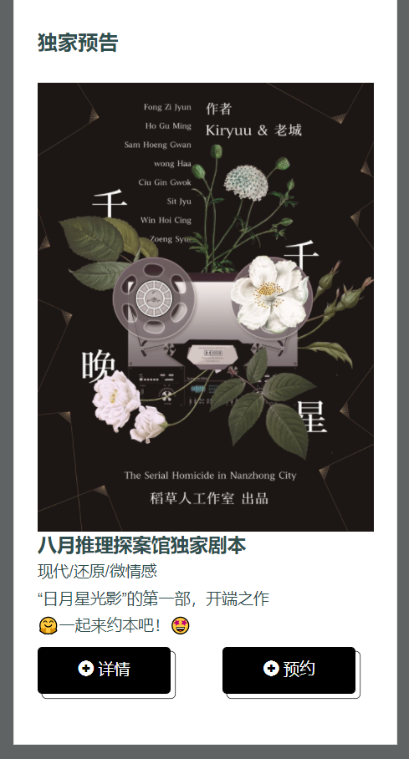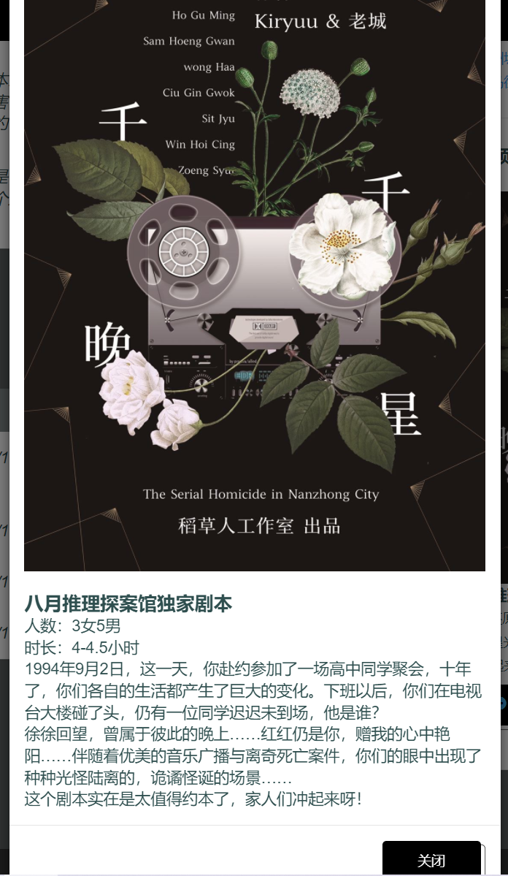

*Figure 21: information & details of exclusive scripts*

1. **Other important functions of the platform**

**Membership**: A membership system has been developed for the platform. The purpose is to increase user retention and build long-term stable relationships with customers through membership, thus increasing their loyalty to promote profits. For general users, they can view the script, venue, forum posts and appointment information available on this site. This satisfies the basic need for ordinary players with the need to find out information related to scripts and venues in Wenzhou. Any user can become a member of this website by filling out personal information on the registration page. Members enjoy the following benefits:

1. Update personal information on the user's personal homepage and record the development of their hobby (see Figure 22). After registration and login, each member will own their customized areas.



*Figure 22: “my page” in the navigation bar*

There two major functions designed for members: profile page and appointment records. The profile page leaves records of the information filled in the registration. Members can update their information on a regular basis on their profile page. Since script murder game players consider this game as a long turn hobby, this page can serve as a note-keeper for them to track development of their interests. This area is designed to enhance user retention.

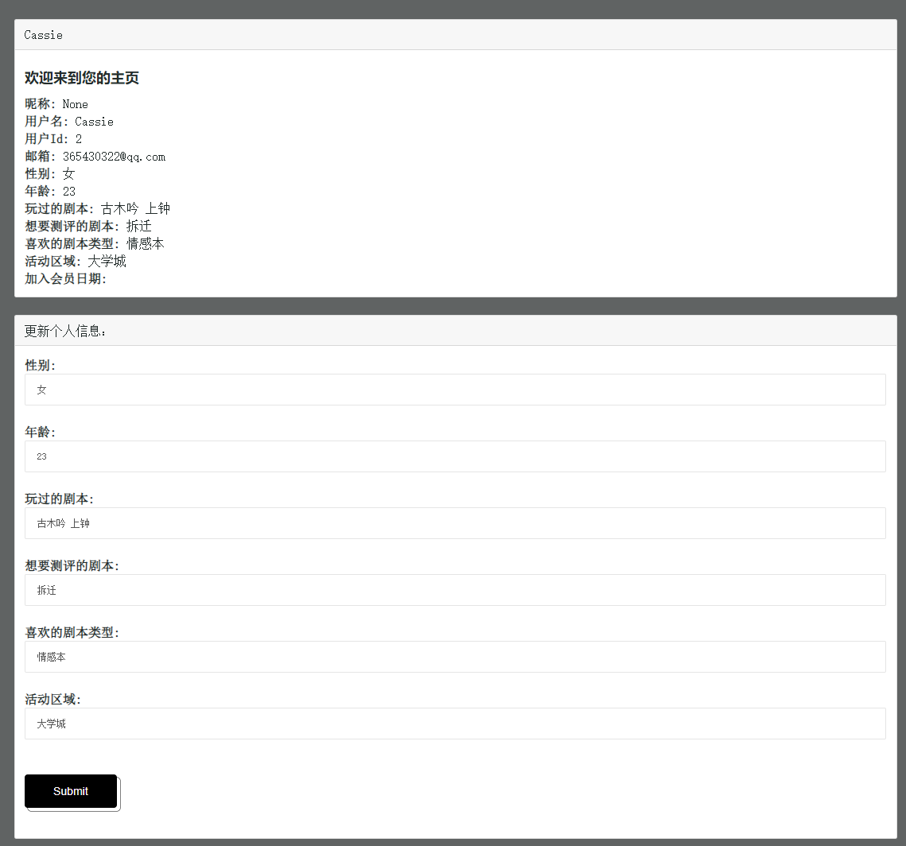

*Figure 23: profile page for each member*

Another function is designed with a page for member to see their appointment records. After making the appointments, they can go to this page to see their orders (see Figure 24).

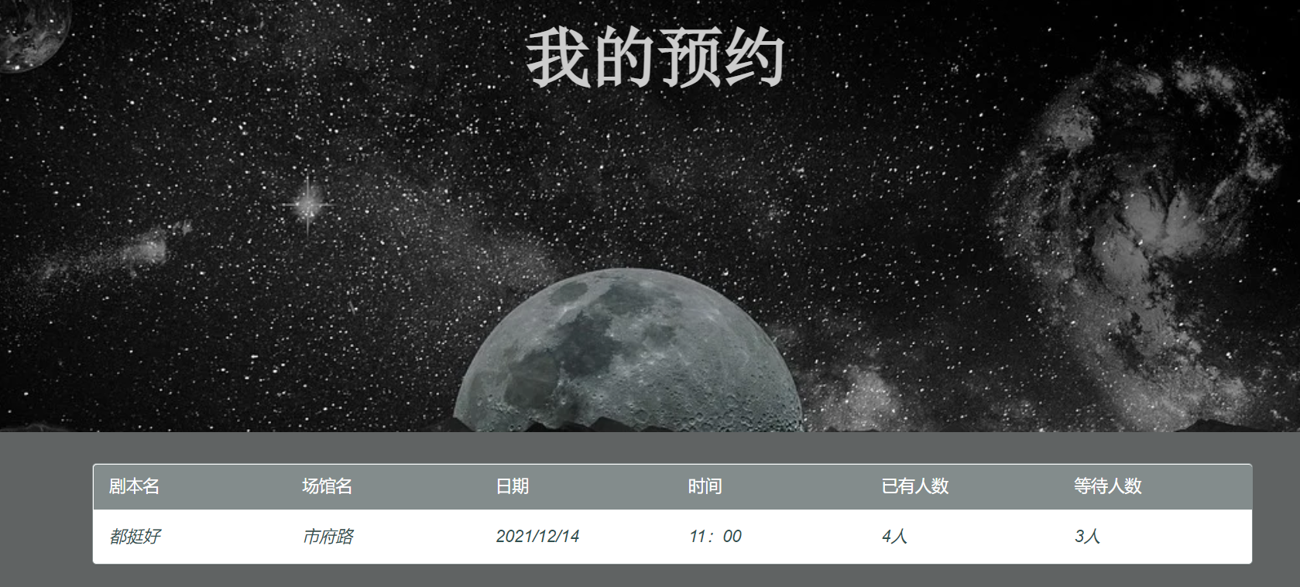

*Figure 24: appointment records page for each member*

One point to mention, only admin user can see and manage the appointment made by all users. (FYI, admin account is Cassie with password 1234) So that admin can clearly see current appointments made and help organize the activities (see Figure 25).

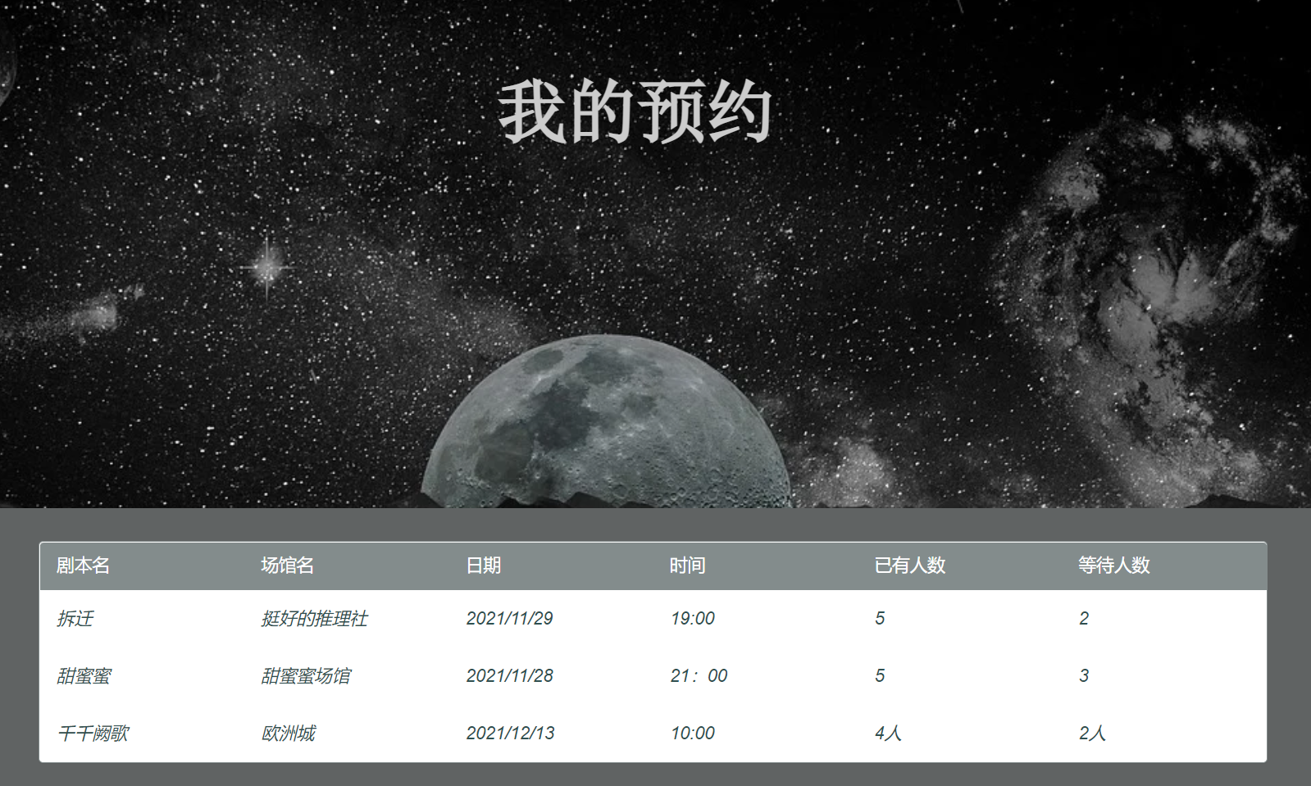

*Figure 25: appointment records page for admin user*

Other benefits for members are:

b) Publishing posts and appointment information about 约本 activity on the forum.

c) Achieve 约本 activity through the appointment system.

These two functions have already been introduced in the previous section.

d) Get the latest information of Wenzhou script murder game venues, scripts, and activities. Emails are proposed to be sent to member to remind them of the latest activities.

The membership rule is shown on the “about” page (see Figure 26).

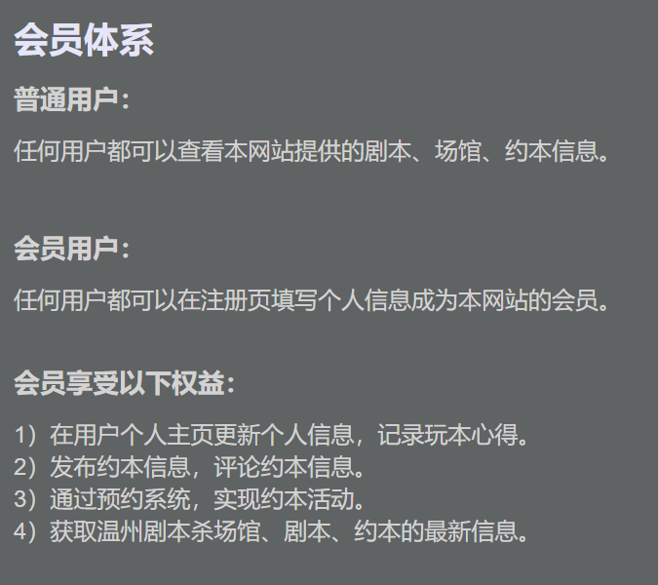

*Figure 26: membership rule on the “about” page*

**Community rules:** At the same time, on the “about” page, rules of the online community have been published and shown on the page, serving as a reference and warning (see Figure 27). If members of the community have published posts against the rules, the admin will delete their posts as well as ban the user account. Since rules are most important for the formation and development of a community, this page will be developed consistently and be added with new rules in the long turn run.

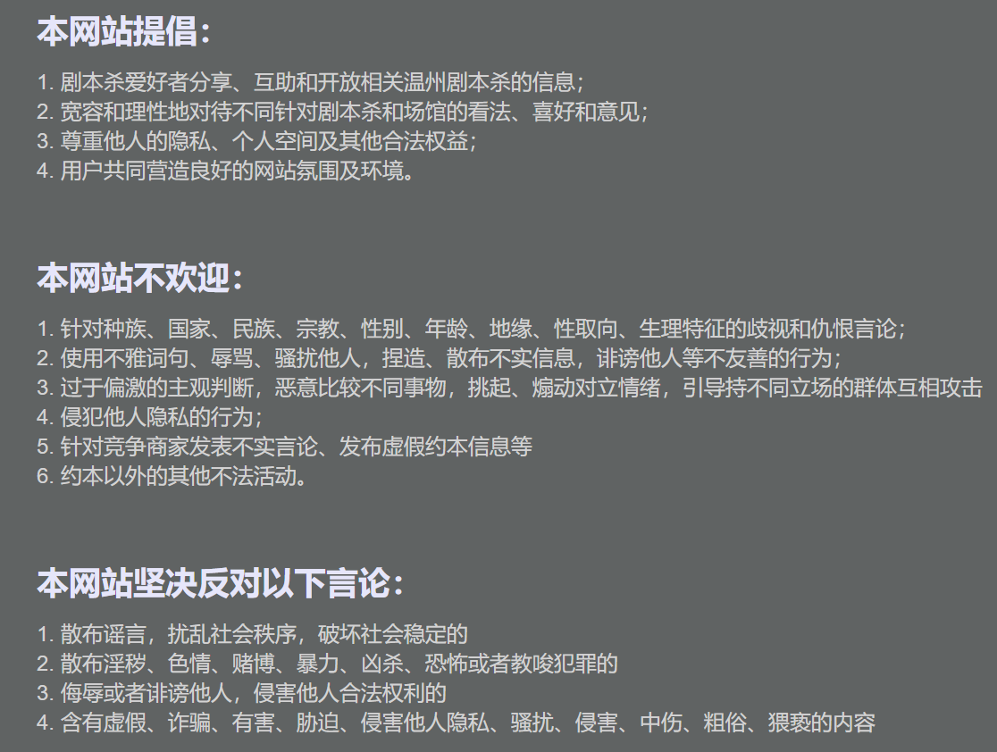

*Figure 27: community rule on the “about” page*

## Business Model

**Target persona:**

On the other hand, from the supply chain side, since the number of customers is limited, venue owners are looking for platforms where they can help their customers organize 约本 activity. And they also find it difficult to let their exclusive scripts known by the public. Therefore, from the supply side, the target persona is venue owners who have the demands of realizing 拼场 activities and advertising venues and exclusive scripts

**Problem settings:**

1. Insufficient brand exposure: currently, venues make advertisements mainly through online and offline channels. Online channels include new media platforms, such as WeChat, Dianping, and Red. The disadvantage of this type of publicity platform is that WeChat is a relatively private channel, and the categories of other platforms are complex, so the target groups are scattered. There is no platform specifically designed for script murder game players in Wenzhou. Offline includes handing out leaflets and advertising through word of mouth, which is more labor-consuming and time-consuming (see Figure 28).

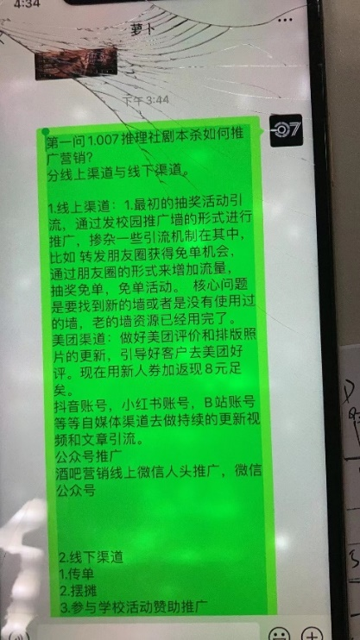

*Figure 28: photo taken of one venue owner talking about the advertising channels*

2. The success rate of 拼场 activities is not high. First of all, after customers determine the scripts that they want to play, the venue needs to help find other players who can join the activity since script murder games require a certain number of players. And their only way to encounter other interested players at present is publishing information in their WeChat group, which means that their customer base is very limited. If it fails to help the customer to get other people to play with, the staff of the venue will act as the players to help realize the activity, which to a certain extent deprives the venue of part of its financial resources, and also consumes manpower and material resources. Therefore, from the perspective of the supply chain, they need more platforms to help publish the appointment activities, not just limited to the WeChat group of their venues.

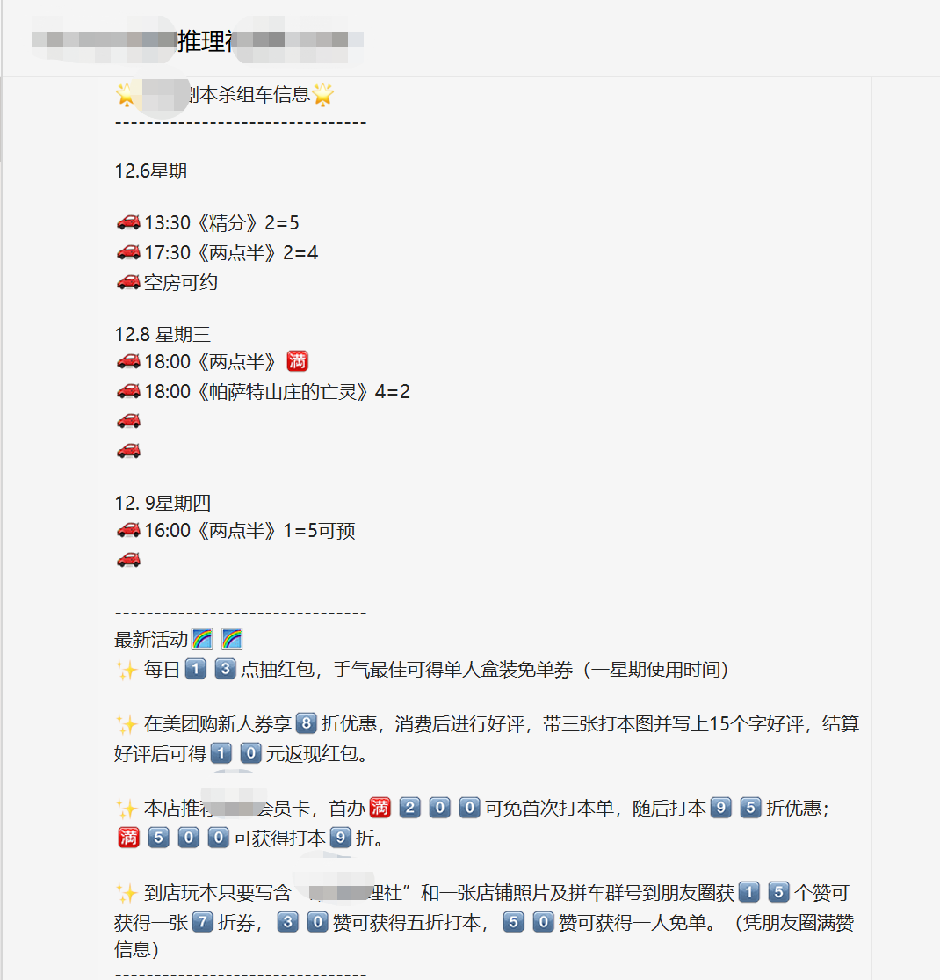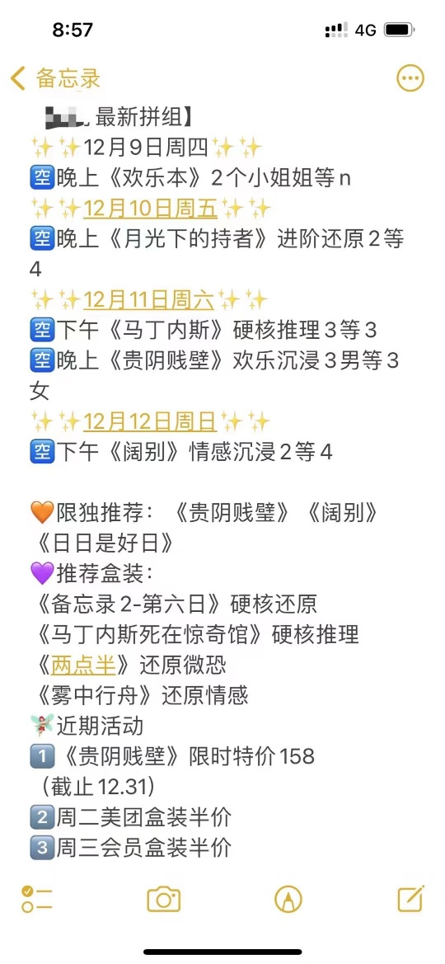

*Figure 29: two pieces of activities invitation of two venues published in their WeChat groups*

3. There are few channels to promote exclusive scripts. Normally, venues need to spend a high price (2000-4000 yuan) to buy an exclusive script, but the channels to promote the script are very limited, usually through WeChat groups and WeChat Moments. Few platforms are suitable for promoting exclusive scripts. As a result, venues may not be able to make up for the purchase cost of the exclusive script, and they may not be able to demonstrate the uniqueness of the venue.

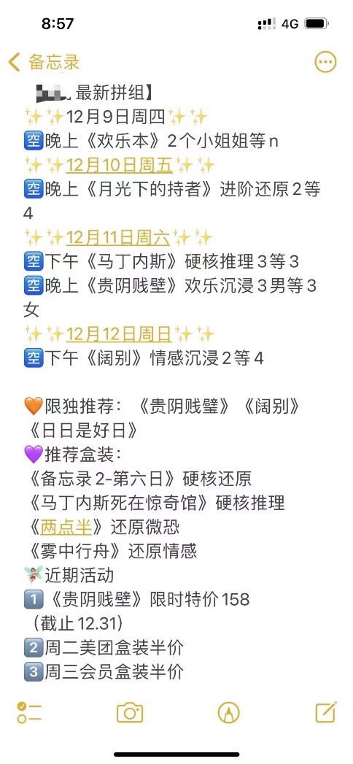

*Figure 30: advertisement of exclusive scripts published in the WeChat group*

**Requirements**

|  |  |  |  |
| --- | --- | --- | --- |
| **Functional** | **Venue exposure** | **拼场 activity** | **Exclusive scripts advertising** |
| **Content** | 1. Which online platforms to publish information about the venue  2. Which platforms to collaborate and pay for advertisement  3. Which offline channels to use to reach the target market | 1. Which platforms to publish information about the activity to satisfy the need of约本 for customers?  2. Which platforms to collaborate and pay for advertisement?  3. If fail to find other players, how to tackle with the situation? | 1. Which platforms to publish advertisement close to the exclusive scripts bought?  2. How to promote the scripts and show them as a differential point? |

Taking into account the potential commercial value, the website has designed a special venue cooperation system and advertising system. Owners can access the page from the navigation.



*Figure 31: cooperation session in the navigation bar*

There two major functions designed for cooperation session:

1. **Verification of venues:** To achieve the verification of venues, owners have to complete three steps to join the platform, which are:
2. Fill out the basic information including venue name, email and contact number in the cooperation form (see Figure 32)

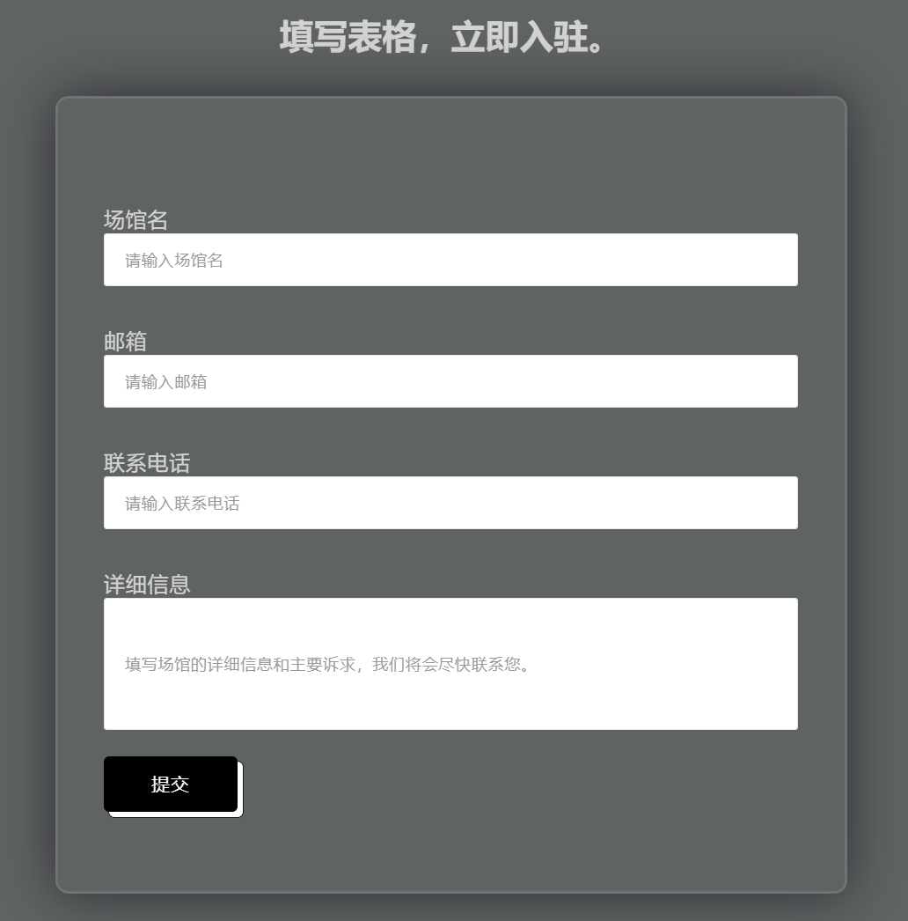

*Figure 32: cooperation form on the cooperation page*

1. Fill in detailed store information (e.g., geographic location, business license, ID number of the legal person, etc.) in the “details” area in the cooperation form
2. After submitting the form, the information will be checked to see whether the venue is legally open in Wenzhou. If the answer is yes, then the owner will be contacted to further communicate about cooperation details.

**

*Figure 33: verification procedures shown on the cooperation page*

Every cooperated venue will be given a unique venue ID for further updating their activities details and satisfying advertisement needs. This is also more convenient for back-end management.

1. **Cooperation plan:** for venues who want to collaborate with the platform, the services are provided as following:
2. Enhance venue exposure: the platform will provide customization for the venue to display their information on the website and adjust the venue's exposure position to help them get seen by more enthusiasts. The service will be billed based on the number of user clicks. The bid for the unit price of a click is between 1.0-2.5 yuan, according to the demands of the venue. In the future, an event listener will be designed on the “view more” button of the collaborated venue to specifically count the number of clicks to the venue.
3. Organize 约本activities: venues can regularly submit activity invitations to the platform, and after verification, the activities will be organized in the discussion forum to help them get new customers and attract traffic. Below the corporation form, there is a button designed for venues that have already decided to collaborate with the platform (see Figure 34).



*Figure 34: “update” button on the cooperation page*

This will direct them to the page to update their activity details in the form (see Figure 35).

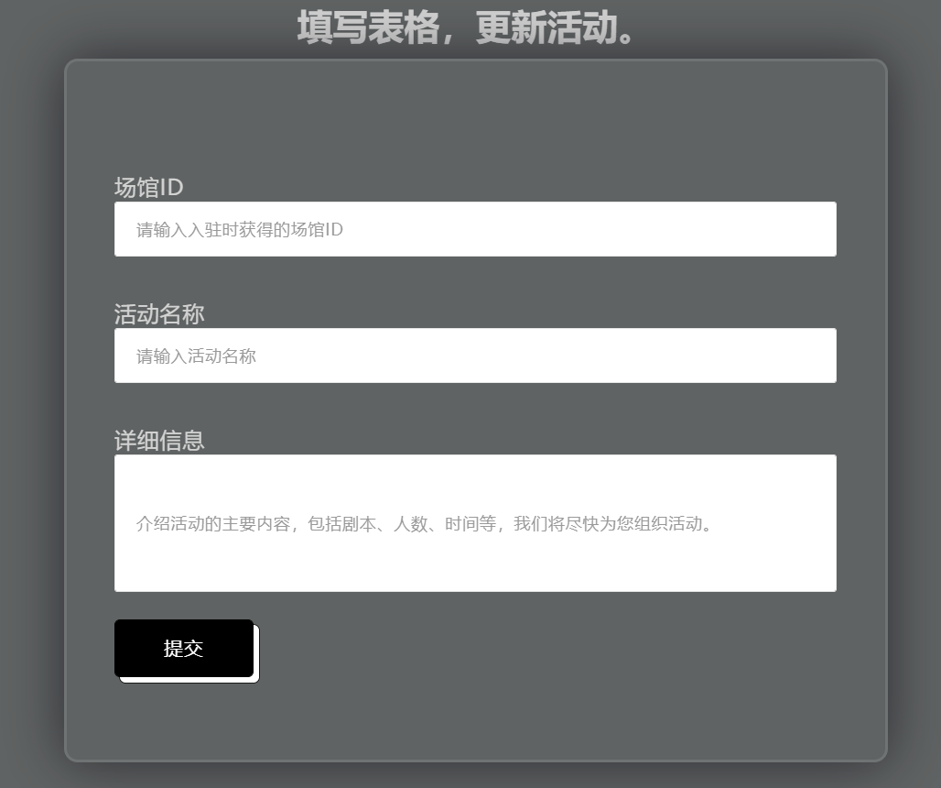

*Figure 35: fill-in forms for venues to update activity information*

After receiving the information and verifying, the platform will help organize their activities in the discussion forum. One example has been posted on the forum (see Figure 36). Because this service helps them organize script murder games and brings financial benefits, the site will charge a percentage of the orders. The expected percentage is 7%. At the same time, since venues also organize lottery of free script murder game chances and free scripts-testing activities on a regular basis, the platform will also discuss relevant cooperation with the venues, as well as organize and publish such free activities for the venues in the discussion area, so as to provide a certain amount of traffic for the venues and websites, which is a win-win cooperation method.



*Figure 36: example of activity organized for venues in the forum*

1. Increase order volume. As the platform provides important services for script murder game players to make appointments, this will benefit venues to attract traffic and gain profit. After receiving the appointments, details will be sent to venues for confirmation and verification. The platform serves as a middleman to communicate between venues and players. This function will help venues increase order volume and thus increase revenue, and the platform will charge venues for each order made here. The expected percentage is 7%.
2. Promote exclusive scripts: The venue's special exclusive script will be placed in the advertising space to increase the exposure of the exclusive script and showcase the venue's unique style. This session is placed on the most important page of the website: the online community page (see Figure 37). Players can click on the “view more” button to see details about the exclusive script, including the number of players required, duration of time, introduction, and advertising slogan. If this interests them, they can directly click on the “appointment” button to make the appointment. This button is designed to convert customers' desire to action in a simple way. The service will be billed based on the number of users clicks and each order related to those exclusive scripts will also be charged expectedly 7% of the revenue gained.



*Figure 37: advertisements for exclusive scripts: information & details*

The corporation proposals mentioned above have also been posted on the cooperation page (see Figure 38). Venues can decide whether or not collaborate with the platform. If the answer is yes, they can fill in the cooperation form. They can also describe their proposal in the “details” area for further discussion.



*Figure 38: cooperation proposals on the cooperation page*

## Evaluation

**Usability test:**

Five tasks were designed to test the usability of the webiste products:

Suppose you want to make an appointment to play the game with other fans:

1. Where would you click to get information

2. How would you get more details and what details would you get

3. Find someone who can play the game with you and consider whether or not to realize a “约本” activity

4. Register and log in

5. Fill in the appointment information and submit

Three post-test questions were also designed to obtain recommendations for improvement:

1. Please rate the overall process: 5 as very satisfied, 1 as very dissatisfied

2. What difficulties did you encounter in the process?

3. How do you think the page can be improved?

**Quantitative results of usability tests:**

**Task Completion Success Rate**

| **Participant** | **Task 1** | **Task 2** | **Task 3** | **Task 4** | **Task 5** |
| --- | --- | --- | --- | --- | --- |
| **1** | **√** | **√** | **√** | **√** | **√** |
| **2** | **√** | **√** | **-** | **√** | **√** |
| **3** | **√** | **√** | **√** | **√** | **√** |
| **4** | **√** | **√** | **-** | **√** | **√** |
| **5** | **√** | **√** | **√** | **√** | **√** |
| **Success** | **5** | **5** | **3** | **5** | **5** |
| **Completion Rates** | **100%** | **100%** | **60%** | **100%** | **100%** |

All participants successfully completed Task 1&2&4&5. Three of the five (60%) completed Task 3.

**Time on Task (seconds)**

|  | **P1** | **P2** | **P3** | **P4** | **P5** | **Avg.** |
| --- | --- | --- | --- | --- | --- | --- |
| **Task 1** | 10 | 12 | 18 | 15 | 8 | 12.6 |
| **Task 2** | 86 | 59 | 99 | 56 | 40 | 68 |
| **Task 3** | 100 | - | 186 | - | 77 | 121 |
| **Task 4** | 123 | 66 | 55 | 47 | 98 | 77.8 |
| **Task 5** | 30 | 25 | 35 | 17 | 20 | 30.5 |

Task 3 required participants to find information about other users that want to play the game and took the longest time to complete (mean = 121 seconds).

Task 4 required users to register with detailed information so it took the second-longest time to complete (mean = 77.8 seconds).

Task 2 is designed for participants to find details and it costs users more time to read and find out more (mean = 68 seconds).

Task 1&5 are straightforward and easy to complete for users, both of which cost little time.

The average score of the process is 3.75, with the lowest rate of 3.0 because the user thought that he could not find much information on the page. He would consider to be a member if there are more activities posted on the forum.

**Recomendations from interviewees:**

From the design part:

1. The page footer widget is too big and seems to be a waste of space.
2. The buttom looks too big and is not compatible to the screen, maybe reduce its size and make it simpler.
3. The thumbnails shown on the scripts page seem are not aligned and look brutal.

From the function part:

1. The map function page and venues details page are separeted and it is difficult for users to directly look for location information on the map of the selected venue. It would be better to combine the two into one page.
2. There is no need to separate the appointment page and the discussion page because they are closely related to each other.
3. Verification of venues should be developed.
4. The registration page requires much information, maybe reduce some parts.
5. If possible, it will be better if users can go to other players’ profile and see detailed information.

From venue owner:

1. The advertising for exlusive scripts is too simple and cannot convey many messages. It is recommendable to expand the area so that users can see more details about it.
2. More details should be provided on the venue details page, more pictures and activities information of the venues
3. The verification of appointment system should be developed so that they won’t receive fake appointments.
4. If possible, develop a page for venues to update time avalability of activities and users can choose and make the appointment easily.

Adjustment made based on the recommendations:

1. The space of the footer part is reduced.
2. The button is redesigend to a smaller size, making it more comfortable to view.
3. The thumbnails on the scripts page have been designed to the same size.
4. The map function has been moved to the venues page so that users can directly look for location information of determined venues on the same page.
5. The appointment funcion and the discussion function have been combined to one page so that users can complete the process of 约本 on one single page.
6. A page for updating activity information is developed for venue owners. It is assumed that after receiving the information, the platform will help organize activities on the discussion page. More advanced automatic updating system(API) will be developed in the next semester while more skills will be leanrt.
7. On the cooperation page, a verification guideline for venues has been developed.
8. One more input has been added to the appointment fill-in form: the contact number of the costmer. Verification phone call or text is to be developed for further verfication and confirmation.
9. The advertisement session for exclusive scripts has been expanded with a modal opened to show details about the scripts. Users can also directly make appointment on the same session. This design has been mentioned before.
10. The registration form remains the same, since this will help verificate whether the member is script murder game player or not and the profile page will be an important part for retenting users.
11. Other adjustments that seem to be diffcult to make will be discussed in the next section: future developments.

**A/B test result:**

At first, to make the functions more clearly separated, the appointment function and the discussion function were designed on two different pages. Since the appointment and forum services are the two most important parts of the platform, they were designed to be tested in the A/B test. This A/B test is designed to see which functions are more important for script murder game players and decide which function to be the main function of the online community. For one thing, a discussion forum allows players to communicate with each other; for another, making the appointment is the crucial part of realizing 约本 activities.

The original version: on the homepage, there are three cards posted to direct users to different pages including scripts collection, venues collections, and the forum. When users click the “view more” button of the forum card, they will be redirected to the forum page (see Figure 39).

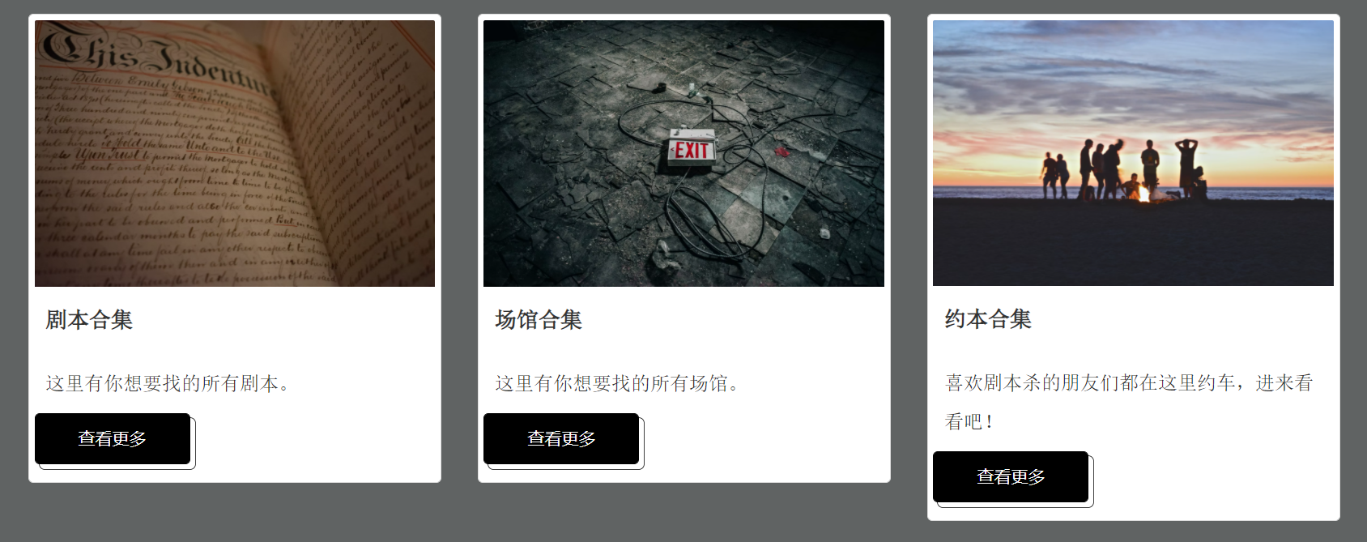

“/blog”

*Figure 39: original version with the “forum” card*

Variable 1: the third card on the page was redesigned. The major function of the card was changed to be the appointment function. When users click on the “view more” button, they will be redirected to the appointment page (see Figure 40).

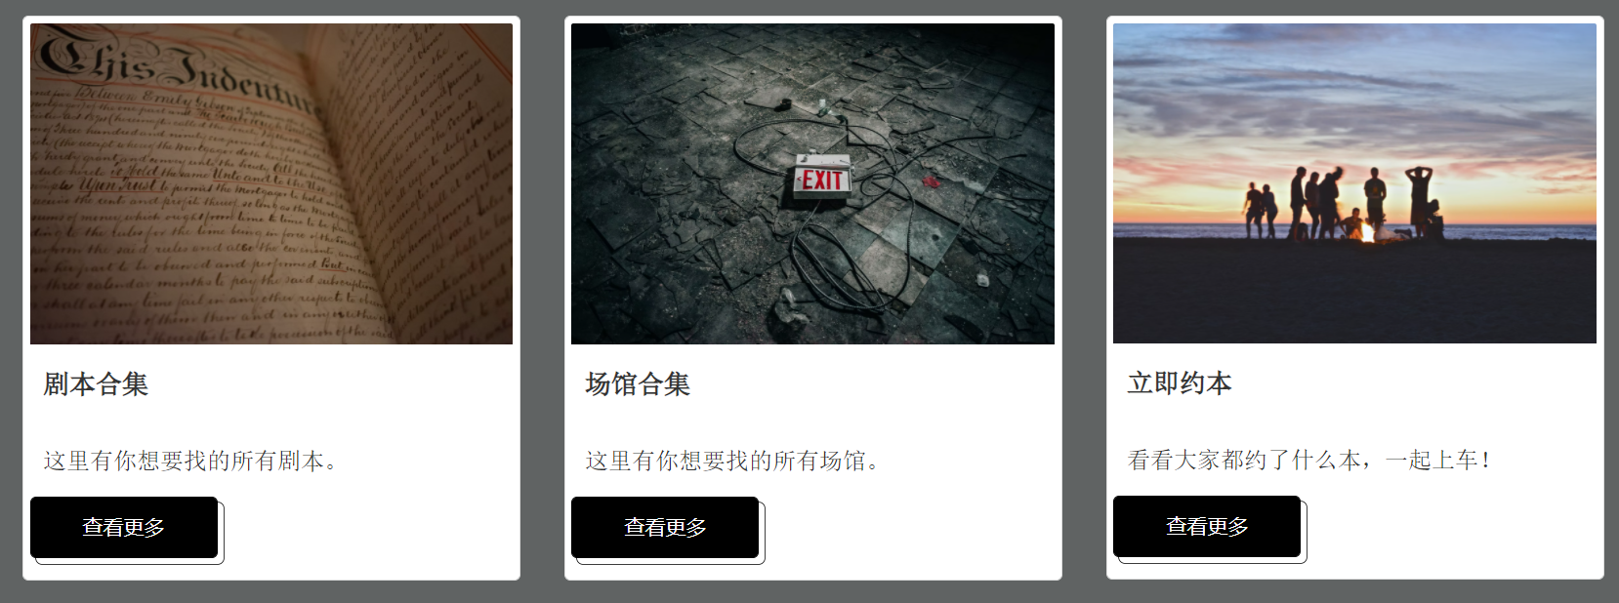

“/appointment”

*Figure 40: variable 1 with the “appointment” card*

From the result, it can be seen that users assigned with the original version and variable 1 version are more or less the same in the duration and pageviews per session (see Figure 41 & 42), with variable 1 performing a little bit better than the original version.

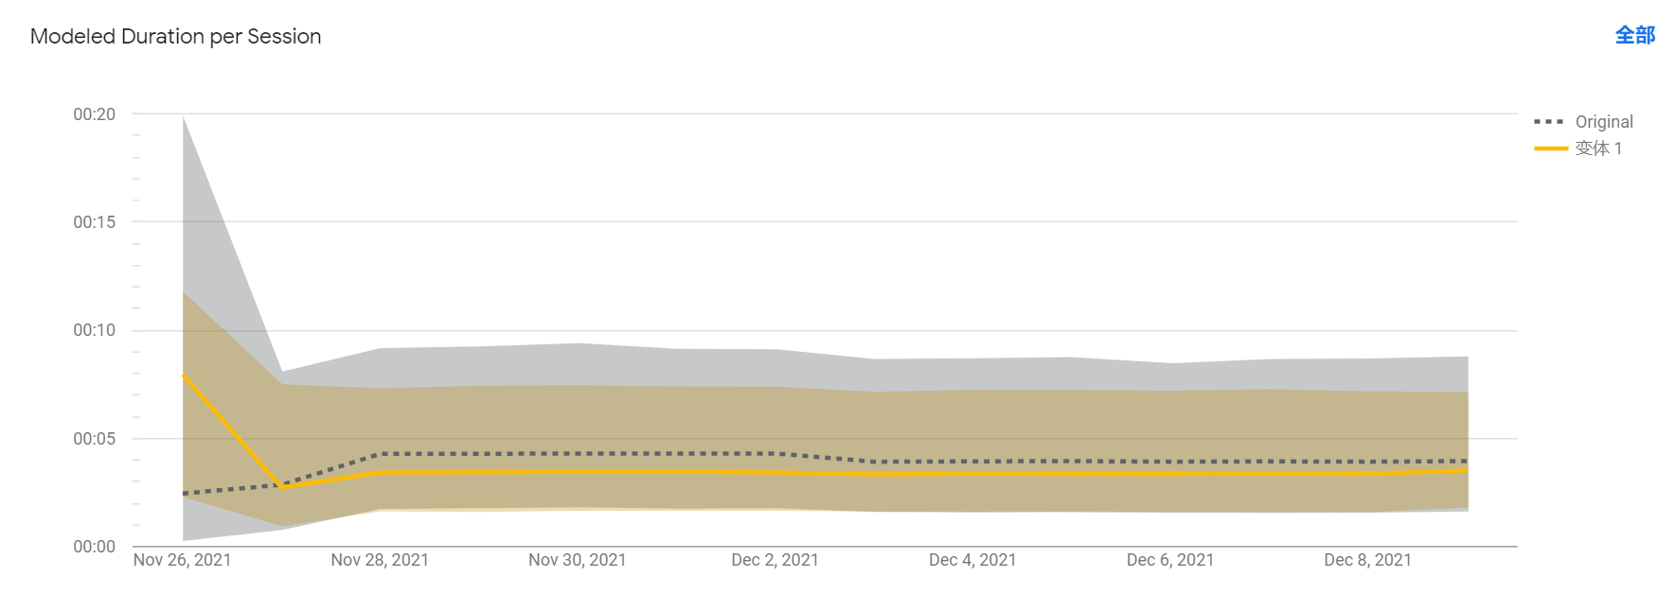

*Figure 41: modeled duration per session*

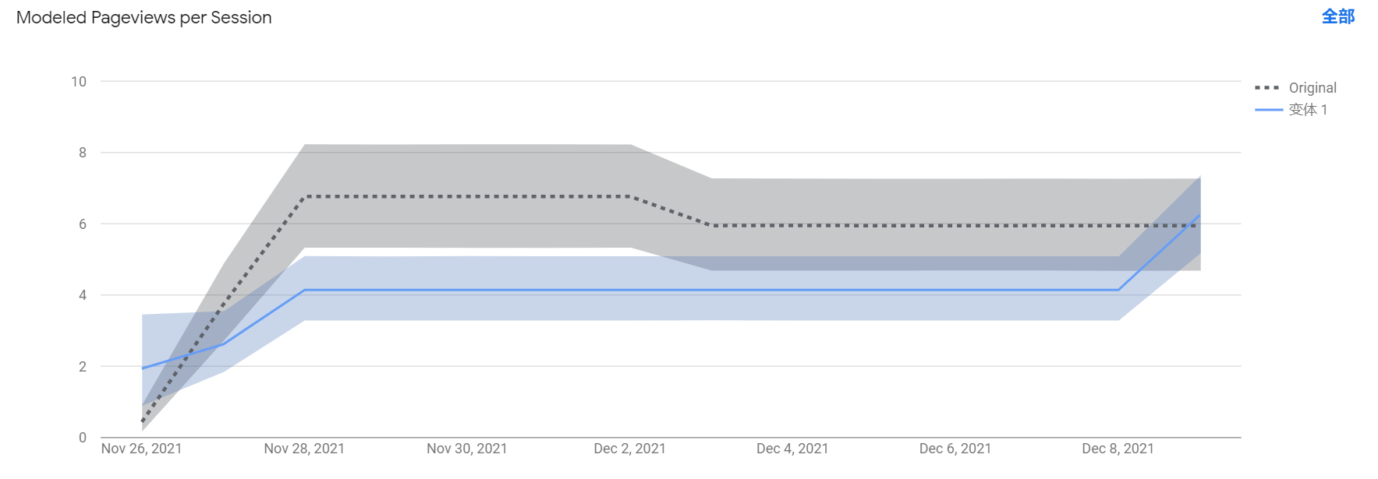

*Figure 42: modeled duration per session*

However, when it comes to the data collected in Analytics, the result seems to be different and leads to controversy. Pageviews of the blog page are much more than those of the appointment page, with the duration of both more or less the same.

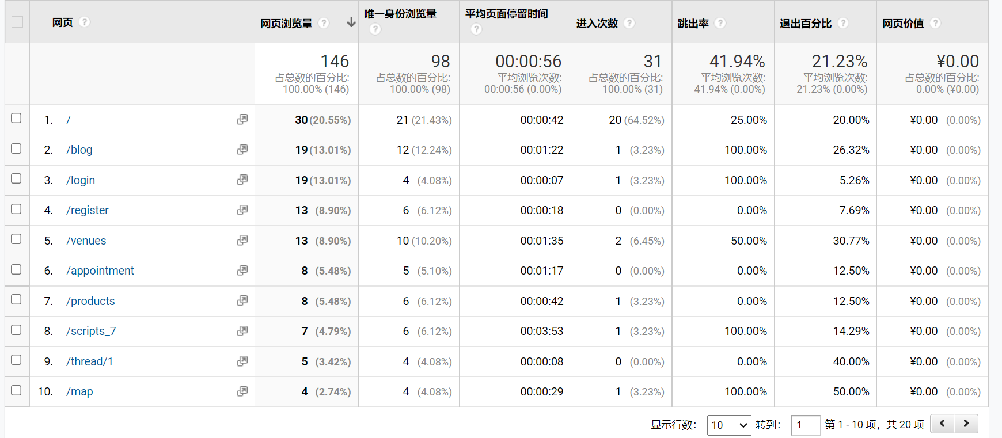

*Figure 43: analytics results (before)*

Combing the two results, as well as recommendations put forwarded by interviewees, the appointment session has been moved to the blog page. Therefore, the two main functions are combined and shown on the same page, and users don’t have to switch from one page to another to make the appointment or communicate with others. They are now allowed to directly click the appointment button after agreeing with other stranger players with the same interest (see Figure 44).

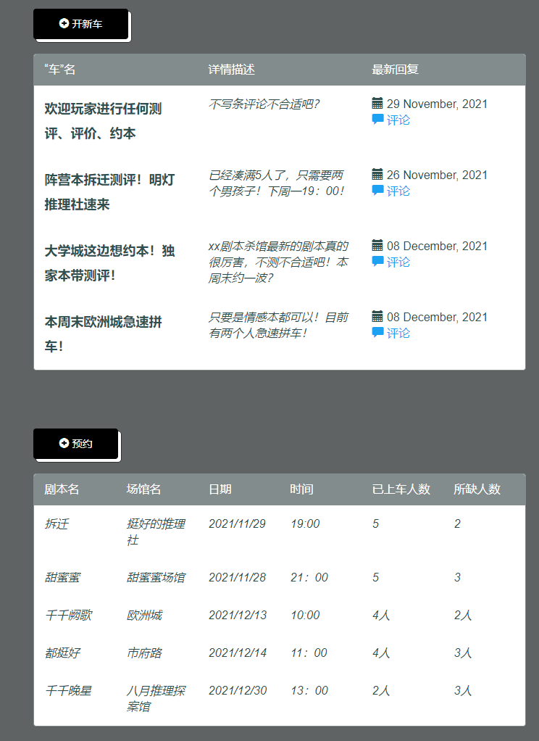

*Figure 44: forum and appointment functions are combined on the community page*

After the improvement, the pageviews are more concentrated on the blog page, which is the expected result, as it is the most important part of the platform.

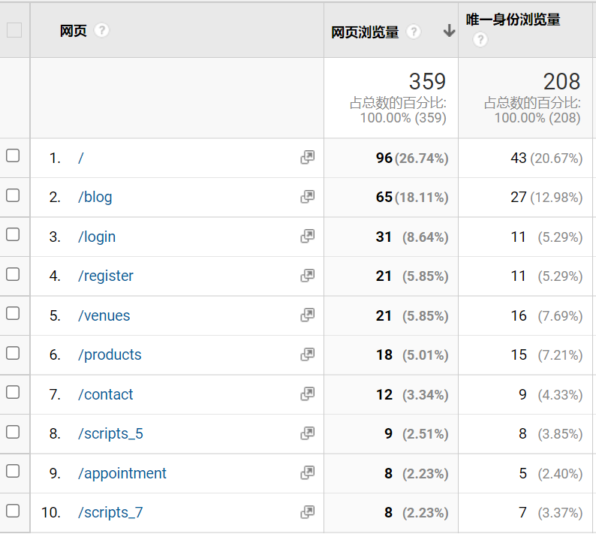

*Figure 45: analytics results (after)*

However, the pageviews of register and login pages are not consistent to that of blog page. Possible reasons are there are not many activities posted yet so visitors don’t consider to be a member; they are not scripts murder game enthusiasts and don’t find it necessary to register; or the membership benefits are not attractive enough for them to register. Further development to improve the platform will be discussed in the next section.

**Recommendations about conducting further development and market studies:**

1. In terms of functional design, the discussion area can be enriched. For example, functions for users to send private messages to each other and to view the others’ homepage to make the social attributes of the platform stronger should be developed in the future.
2. The website needs to build its own API in the future. One aim is to allow related service provider to access the website and connect the service through the API, and the other is to have a partner-oriented platform for venue partners to manage their data and page.
3. On the basis of API, each venue's own detail page can be built, allowing venues to update the latest event details, which is more convenient for website operation and maintenance in a long turn run; at the same time, the detail page can also add users’ rating and commenting functions.
4. Upgrade a more advances user verification system, such as a mobile phone verification code, to ensure that the user is not maliciously leaving comments or click farming.
5. Guide users to form the minds of writing and publishing reviews and comments, as well as improve the authenticity of the discussion area and the timeliness of feedback. This will aslo help improve registration rate. First, a mechanism related to membership grades can be introduced to give points rewards or coupons to users who post reviews and book appointments on the platform. High-level users will be prioritized in the activities. In the later stage, when there is a certain basis for orders and venues to settle in, and more cooperation can be discussed with venues (e.g., see Figure 46)



*Figure 46: other kinds of activities organized by venues (screenshot from a venue’s WeChat group where I am in)*

**Appendix**

Interviews of target persona:

**Interview Questions:**

1.When carrying out a 约本 activity, you will first determine the venue or first determine the script?

**Venue first**:

2. Which websites or information sources will you rely on to obtain concert related information?

3. What information would you click on from this website or app to view? Can you show me?

4. How do you find out about a venue in the determined location?

5. Do you check the comments of the venues? Where will you inquire?

6. How do you check the number of people required and time availability of the scripts of the venue?

7. Do you look up introductions to plays and reviews? Where would you look up?

**Script first**:

2. Which websites or information sources will you rely on to obtain concert related information?

3. What information would you click on from this website or app to view? Can you show me?

4. How do you find out about a script you wanted to play? Or, through which way do you find out about a script that interests you?

5. Do you look up reviews, introductions, etc. of plays? Where do you check?

6. How do you find out about a venue that has that play? Do you look up its reviews?

7. How do you determine the venue location and available times?

8. How do you find other players or buddies to play with?

9. How do you communicate with each other and determine the scripts or venues or time?

10. How do you make the appointment after certain degree of agreement?

11. Is the navigation bar/information shown clear enough?

12. Is the function of each part clear enough? What part could be improved and how?

13. What content should be added?

14. Is this information resource helpful if you are going to plan a 约本 activity?

Usability interviews:

**Participant Profiles:**

|  | **Age** | **Frequency of playing the game** | **Average money spent** |
| --- | --- | --- | --- |
| Participant 1 | 20 | 1-2 times a week | 700-800 RMB per month |
| Participant 2 | 23 | 4 times approximately a month | 400-500 RMB per month |
| Participant 3 | 23 | At least once a week | Around 800 RMB per month |
| Participant 4 | 24 | About 4-5 times a month | 100 RMB a week |
| Participant 5 | 25 | 3-4 times a month | Around 500 RMB per month |

Bootstrap used for the website:

<https://startbootstrap.com/theme/clean-blog>

Figma prototypes link:

<https://www.figma.com/file/RlTE7xQdGI8NJWogNIhSNs/app?node-id=32%3A4907>

Data scraped from 3rd party websites used for the website:

Scripts’ information including scripts name, time duration, types, authors and introduction: 我爱剧本杀官网：<http://m.vshang66.com/juben/>

Venues’ information including rating, name, district, events information, address and contact number: 大众点评官网： <https://m.dianping.com/>

Map information: API from GaoDe Map : <https://lbs.amap.com/>